Strategically mitigating the impacts of offshore wind on marine fisheries can also promote climate resilience
Christopher M. Free¹*, Kelly S. Andrews⁴, Pol Carbó Mestre^{1,2,3}, Blake E. Feist⁴, Steven D. Gaines², Ana Sofia Guerra⁴, Tracey Mangin^{1,2,3}, Jameal F. Samhouri⁴, Donna M. Schroeder⁵, Ellen Willis-Norton⁶

¹ Marine Science Institute, University of California, Santa Barbara, Santa Barbara, CA, 93106, USA
² Bren School of Environmental Science and Management, University of California, Santa Barbara, Santa Barbara, CA, 93106, USA
³ Environmental Markets Lab, University of California, Santa Barbara, Santa Barbara, CA, 93106, USA
⁴ Conservation Biology Division, Northwest Fisheries Science Center, National Marine Fisheries Service, National Oceanic and Atmospheric Administration, Seattle, WA, 98112, USA
⁵ Bureau of Ocean Energy Management, 760 Paseo Camarillo, Camarillo, CA 93010, USA
⁶ Port of San Diego, San Diego, CA, 92101, USA

* Corresponding author: Marine Science Institute, University of California, Santa Barbara, Santa Barbara, CA, 93106, USA; cfree14@gmail.com

Target journal: Marine Policy

Abstract (249 of 250 word maximum)
Offshore wind (OSW) is expanding as a source of renewable energy but is expected to displace and negatively impact marine fisheries. While tools for avoiding and minimizing these conflicts through marine spatial planning are well-established, there is little guidance on mitigating the unavoided impacts. We reviewed current and proposed fisheries mitigation plans to develop a comprehensive menu of strategies for offsetting the socioeconomic impacts of OSW development and assessed the extent to which these strategies also build long-term climate resilience. Our review identified 60 mitigation measures grouped within 25 broader mitigation strategies. The identified strategies extended beyond direct financial compensation to include investments in port infrastructure, seafood marketing, workforce development, fisheries science, governance participation, vessel safety, and other initiatives. The identified mitigation strategies offer strong support for socioeconomic resilience and moderate support for resilience in governance but offer weak support for ecological resilience. Most of the identified strategies could be financed, implemented, and enforced through community benefit agreements (contractual agreements between OSW project developers and impacted communities) in close partnership with local business, regulatory, educational, and research institutions. Although all of the identified mitigation strategies represent fisheries subsidies, many of which are capacity-enhancing, most are not harmful when governance is strong. We envision that this menu of mitigation strategies could be used to strategically design mitigation plans that diversify their support for long-term resilience when offsetting the impacts of OSW development and other emerging ocean uses (e.g., aquaculture, oil/gas/mineral extraction, protection), on marine fisheries.

Keywords (7 word maximum): wind energy, mitigation, compensation, avoidance, minimization, community benefit agreements

Highlights (3-5 bullets; 85 characters max)
- Offshore wind is a growing source of green energy but can negatively impact fisheries
- We reviewed mitigation strategies and their support of long-term climate resilience
- The identified mitigation strategies strongly support socioeconomic resilience
- Governance and ecological resilience are moderately and poorly supported, respectively
- These strategies can also be used to mitigate the impacts of other emerging ocean uses

1. Introduction
Climate change threatens global food systems and economies (Wheeler and von Braun, 2013), incentivizing renewable energy that reduces emissions and prevents catastrophic impacts (Hoegh-Guldberg et al., 2019; Rogelj et al., 2015). Offshore wind (OSW) is expanding as a source of renewable energy due to greater wind consistency and space availability in the ocean compared to land (GWEC, 2025). Although marine fisheries are negatively impacted by climate change (Free et al., 2019) and are predicted to experience long-term benefits from emissions reductions (Cheung et al., 2016; Gaines et al., 2018), they are also likely to experience negative short-term impacts from expanded OSW development (Gill et al., 2020). Notably, OSW development displaces fisheries, potentially resulting in lost fishing grounds, crowding, lower catch rates, greater travel times, and higher fuel expenditures (Warlick et al., 2025; Willis-Norton et al., 2024). While OSW sites could generate fisheries benefits by acting as de facto protected areas and artificial reefs, which can both increase local catch rates, evidence for these benefits is tenuous and may be offset by the negative impacts of displacement ((Gill et al., 2020) but see (Campbell et al., 2026)). Limiting the short-term impacts of OSW development is thus critical to ensuring the long-term viability of fisheries and to reducing opposition to an important source of renewable energy.

The negative impacts of OSW development on marine fisheries can be reduced through avoidance, minimization, and mitigation (BOEM, 2025). Avoiding impacts by siting OSW in areas without fishing is one option but is challenging when the best fishing grounds and wind areas overlap (Feist et al., 2025). Minimizing impacts through effective OSW siting, design, and communication is an alternative when impacts cannot be fully avoided. For example, impacts can be minimized by siting OSW in windy areas of low fisheries importance or by arranging turbines and cables in ways that limit displacement (Boussarie et al., 2023; Carlton et al., 2023; Harvey et al., 2025; Zhang et al., 2017). Finally, mitigating impacts that remain after avoidance and minimization efforts is a last, though nearly universal, resort (Szostek et al., 2025). Potential mitigation measures include the compensation of impacted fishermen through direct monetary payments and/or through investments that indirectly benefit impacted fishermen by bolstering their income, resilience, or well-being (Reilly et al., 2016). Though avoidance and minimization is supported by a rich literature on marine spatial planning (Boussarie et al., 2023; de Groot et al., 2014; Stelzenmüller et al., 2022; Zhang et al., 2017), the role of mitigation, especially in offsetting impacts through strategic investments, is relatively underexplored (Reilly et al., 2016).

While mitigation measures directly pertaining to OSW development and the fisheries it displaces offer the most linear pathway for mitigating OSW impacts, measures that bolster against other stressors or support less-displaced fisheries may be as or more effective. In many places, fishermen participate in fisheries outside those affected by OSW development, which suggests that measures that improve the profitability or resilience of these other fisheries could offset losses from those affected by OSW. Similarly, OSW development is just one of many stressors confronting fishermen, who must also contend with climate change, increasing operating costs, market fluctuations, changing management restrictions, and rising spatial conflicts with marine protected areas (MPAs), aquaculture, and other emerging ocean uses (Trifonova et al., 2025). Thus, measures that holistically increase the resilience of fisheries offer long-term benefits and broaden the range of strategies available for mitigating OSW impacts.

The profits generated from OSW development present a pathway for financing fisheries mitigation measures through either legal requirements or effective incentive mechanisms. For example, in the United States, Community Benefit Agreements (CBAs), which are legally binding and enforceable contracts between project developers and impacted community groups, present a promising mechanism for defining, financing, and enforcing mitigation (Hoff and Segal, 2023). These contracts could dictate how energy companies compensate displaced fishermen, refund lost or damaged gear, improve port infrastructure, support community projects, retrain fishermen for alternative employment, or support any other measures identified by the impacted community (CA CFOs, 2022). In return, CBAs often require that the impacted community formally support the planned OSW project, or at least refrain from outwardly opposing it, which lowers long-term litigation and mitigation costs (Hoff and Segal, 2023). Although CBAs have been widely used in land-based development projects, their application in offshore projects is nascent and existing examples rarely include fisheries-specific mitigation strategies (Hoff, 2024). As OSW expands (GWEC, 2025), there is great need for guidance on actions that could mitigate the impacts of OSW development on fishing communities.

The goal of this paper is to provide a menu of measures for mitigating the impacts of OSW development on marine fisheries through strategies that increase both income and long-term resilience. We develop this menu through a telescoping review procedure that narrowly begins with a California (U.S.) case study and methodically widens the field of view to examine other U.S. offshore wind farms and mitigation guidance. We identify the elements of climate resilience supported by the curated mitigation measures to help planners strategically select strategies that provide long-term benefits. Finally, we discuss the strengths, weaknesses, and special considerations associated with many of the identified mitigation strategies. We envision that this menu of mitigation strategies could also be used in the context of building long-term resilience in response to other ocean uses that impact marine fisheries, including the expansion of offshore aquaculture; critical minerals mining; oil, gas, and other renewable energy extraction; and ocean protection.

2. Methods

2.1 Overview
We used a “telescoping” review procedure to identify mitigation measures that narrowly begins with a specific case study (planned OSW areas in California) and methodically widens the field of view to other sources. Specifically, we extract mitigation measures from six sources: (1) focus group discussions held with fishermen from three U.S. West Coast port communities; (2) a CBA between Castle Wind LLC and one California commercial fishing organization; (3) a CBA template proposed by sixteen California commercial fishing organizations; (4) mitigation guidelines prepared by the 7c Working Group; (5) CBAs already implemented for other offshore projects in the U.S; and (6) recent government guidance on mitigating OSW impacts on fisheries in the U.S.. We extracted distinct mitigation “measures” from each source then grouped them into broader mitigation “strategies.” As a result, each broad mitigation strategy is exemplified by specific mitigation measures. Finally, we identified which attributes of climate resilience (Mason et al., 2022) are supported by each mitigation strategy. This serves two functions. First, it reveals the preferences and shortcomings of each source of mitigation measures regarding measures that support resilience. Second, it allows designers of future fisheries mitigation plans to consider mitigation strategies that support each realm of climate resilience. All analyses were done in R (R Core Team, 2026) and all non-confidential data and code associated with the manuscript are available on GitHub here: https://github.com/cfree14/osw_mitigation_measures

2.2 Case study
The first OSW farms on the U.S. West Coast have been planned for two areas off of California (Fig. 1A). The Morro Bay wind energy area (975 km²) is over 31 km (>867 m deep) off of Morro Bay in Central California while the Humboldt wind energy area (536 km²) is over 32 km (>510 m deep) off of Eureka in Northern California (Boren, 2021; Liu, 2021). These areas were identified by the Bureau of Ocean Energy Management (BOEM), the U.S. federal agency that permits and regulates ocean energy projects in federal waters, through a 5-year data- and stakeholder-informed planning process (BOEM, 2026a). Ultimately, the areas were sited based on revisions following two rounds of public comment, plus an initial round of outreach by Trident Winds LLC, the wind company that first proposed an OSW project in the Morro Bay area. Although the areas were successfully auctioned and leased (three lease areas in Morro Bay and two lease areas in Humboldt) in 2022, site characterization and other developer activities are stalled due to changes in federal priorities (The White House, 2025). At the time of writing, three winning companies have relinquished their lease areas (two within the Morro Bay wind energy area and one within the Humboldt wind energy area), though the state of California is disputing the legality of these arrangements (CA DOJ, 2026).

The commercial fishing industry anticipates large and diverse negative impacts from OSW development in California (CA CFOs, 2022). The principal concern regards loss of access to fishing grounds, especially for highly migratory species and deepwater groundfish, within the lease areas. This is expected to reduce catches and increase transit times, resulting in higher fuel expenditures, lower product quality, and more time away from family. There are also concerns that OSW development may reduce safety at sea, stifle climate adaptation, hinder scientific monitoring, harm the environment, and hurt stock health. Fishermen also anticipate that increased port activity will disrupt normal transit patterns and increase competition for limited harbor space, which could price out fishing vessels. Finally, fishermen are worried about the erosion of community identity, dilution of the symbiotic relationship between fishing and tourism in small coastal towns, and increased personal and family stress due to increased economic strain and time at sea. This summary highlights only a fraction of the concerns raised by sixteen California commercial fishing organizations in a letter to regulators (CA CFOs, 2022).

While BOEM did not explicitly require wind developers to mitigate impacts in the lease stipulations, the leases introduced a new bidding mechanism to incentivize fisheries mitigation in its auction of the California lease areas (BOEM, 2022a). Specifically, BOEM gave companies the option to increase the total value of their bid by committing up to 30% of their cash bid to (1) workforce training and supply chain development (20% cap), (2) “Lease Area Use CBAs” with commercial or tribal fishing entities that rely on resources harvested within the lease area (5% cap), or (3) “General Use CBAs” with any entity affected by OSW development, including development activities occurring outside the actual lease areas (5% cap). The leases established basic requirements for each type of CBA, but the specific provisions are to be developed collaboratively between the lessees and the affected entities through long-term engagement. Developers were incentivized to commit funding toward CBAs, because they received bidding credits for doing so, increasing the value of their bids, while also potentially helping to address stakeholder concerns. Nearly all the winning bids included this option, resulting in $117.4 million for workforce training, $29.4 million for CBAs for fisheries-specific mitigation, and $23.3 million for CBAs for general community mitigation (BOEM, 2026b).

2.3 Focus groups
We conducted focus groups in three ports along the U.S. West Coast to discuss the observed and expected impacts of OSW development and climate change on fisheries and potential strategies for mitigating these impacts. These ports – Morro Bay (Central California), Eureka (Northern California), and Newport (Central Oregon) – were selected due to their proximity to the recently leased wind energy areas and other areas proposed in Oregon (Fig. 1A). We recruited 3-7 fishermen (one harbormaster also participated) to each focus group (Newport=3 participants, Eureka/Morro Bay=7 participants each). Participants were recruited through a combination of direct outreach to existing professional contacts and through snowball sampling. For the latter, we contacted leaders of commercial fishing organizations, who invited participants from their professional networks. We facilitated a structured conversation to first discuss observed and expected impacts of OSW development and climate change on local fisheries and then to discuss potential strategies for mitigating both impacts (see Appendix A for details). After each focus group, we identified distinct mitigation measures proposed by participants from our notes. Our research protocol (#1-23-0595) was reviewed and approved by the University of California, Santa Barbara Internal Review Board.

2.4 Community benefit agreements
We extracted mitigation measures from proposed and implemented CBAs for mitigating the impacts of OSW projects on neighboring communities. These included: (1) a CBA drafted, though never implemented, between a wind company, a city, and two commercial fishing organizations related to the Morro Bay lease area (section 2.4.1); (2) a CBA template proposed by sixteen California fishing organizations for future CBAs with the winning wind companies (section 2.4.2); (3) a CBA template proposed by a state-mandated working group of key constituents (section 2.4.3); and (4) CBAs implemented between wind companies and communities elsewhere in the U.S. (section 2.4.4). These CBAs are described in detail below.

2.4.1 Castle Wind CBA
Before the 2022 auction of the California lease areas, Castle Wind LLC, a joint venture between Trident Winds LLC and TotalEnergies, negotiated and signed a CBA with the City of Morro Bay and two commercial fishing organizations (Morro Bay Commercial Fishermen’s Organization and Port San Luis Commercial Fishermen’s Association). The CBA guaranteed job training, infrastructure improvements, and other benefits for fishermen impacted by the proposed wind project. Through the CBA, the city of Morro Bay also gave Castle Wind the exclusive option to lease an outfall conduit near the Morro Bay power plant that could deliver offshore electricity to the Morro Bay Substation, illustrating the benefits that CBAs can generate for developers. Although Castle Wind did not ultimately acquire a lease in the 2022 auction, this CBA serves as a starting point for those that could be developed between winning bidders and fishing communities and offers a range of fishermen-endorsed mitigation measures.

2.4.2 California fishing organization CBA template
In 2022, sixteen California commercial fishing organizations, including both organizations involved in the Castle Wind CBA, co-signed a letter to regulators (CA CFOs, 2022) to share a template for a CBA or other legal entity that could be used to manage the impacts of OSW development on California fisheries. Broadly, the document suggests that the entity would negotiate with OSW companies for financial compensation in addition to other types of mitigation and would facilitate communication between the wind company and fishermen. It envisions the distribution of an initial one-time payment as well as continued funding for the duration of the project. It recognizes that more than one entity may be needed to address different regional needs but suggests that the overall purpose and structure of the proposed template is transferable. It also suggests that the model may apply to future development projects, such as offshore aquaculture, that may result in fisheries displacement.

2.4.3 7c Working Group
The U.S. Coastal Zone Management Act requires that all federal activities affecting the coastal zone be consistent with a state’s coastal management program. Thus, as part of the lease approval process, BOEM was required to evaluate the consistency of the proposed lease activities with California state law for the California Coastal Commission to then approve or reject. The California Coastal Commission determined that the proposed lease activities were consistent with California's Coastal Management Program conditional on seven requirements (CCC, 2022a, 2022b). Notably, Condition 7(c) called for the development of a “Statewide Strategy for the Coexistence of California Fishing Communities and Offshore Wind Energy.” In 2023, the “7c Working Group” – composed of representatives from fisheries, fishing organizations, wind companies, and tribes – was convened to draft a statewide strategy for “addressing impacts to the commercial and recreational fishing industries, tribal fisheries, and environmental resources associated with offshore wind energy projects.” The statewide strategy, colloquially called the “7c Working Group Report”, was released in 2026 (7c Working Group, 2026). This document is intended to serve as the authoritative guide for avoiding, minimizing, and mitigating the impacts of OSW development on California’s fishing communities.

2.4.4 Other CBAs developed for offshore or land-based wind projects
In the U.S., CBAs have already been implemented for several offshore wind projects. We reviewed 14 offshore wind agreements (Fig. 1) collated by the National Laboratory of the Rockies in the WINDExchange Local Benefit Mechanisms Database (NREL, 2024) for distinct mitigation measures. When the CBA was not publicly available (Table S1), we reviewed related news articles for relevant information.

2.5 BOEM mitigation guidelines
In November 2021, BOEM published a “Request for Information” to obtain input from the public, especially the fishing community, on avoiding, minimizing, and mitigating the impacts of OSW development on commercial and recreational fisheries (BOEM, 2021a). The 45-day comment period resulted in 92 public comments (BOEM, 2022b). During this time, BOEM also hosted a series of workshops with commercial and recreational fishing communities spanning the East, West, and Gulf Coasts (BOEM, 2021b). BOEM published Draft Fisheries Mitigation Guidance in June 2022 (BOEM, 2022c), which received 87 comments during the following 60-day public comment period (BOEM, 2022d). During this time, BOEM hosted another round of regional workshops with commercial and recreational fishing communities to facilitate direct feedback from fishermen (BOEM, 2022e). In 2025, BOEM published a national framework for addressing the social and economic impacts of OSW development on the fishing industry (BOEM, 2025). While the draft guidance, public comments, and workshop notes provide a rich database of potential mitigation measures, we only evaluated the final guidance because of its regulatory authority and significance.

2.6 Mitigations measures database
We collated the mitigation actions identified from the six sources described above into a single database. We then reviewed these actions and generalized them into 60 distinct mitigation “measures” using grounded theory (Morgan et al., 2001). For example, “[fund] radar system upgrades [to improve safe navigation]” and “[provide] safety and navigation equipment grants” were both generalized as “provide vessel safety equipment.” We then grouped mitigation measures into 25 distinct mitigation “strategies”, which capture the broader purpose of each mitigation measure. For example, “provide vessel safety equipment” and “provide vessel safety training” were grouped under “provide vessel safety equipment and training.” As a result, each mitigation measure represents a tactical example of a broader mitigation strategy (Table 1).

We then identified the attributes of climate resilience supported by each mitigation strategy. The attributes of climate resilience were adopted from the framework put forth by Mason et al. (2022). Through a coupled literature- and expert-driven approach, Mason et al. (2022) defined 38 ecological, socioeconomic, and governance attributes theorized to confer climate resilience in marine fisheries. Within the ecological, socioeconomic, and governance dimensions, these attributes are organized within three to five resilience domains (Cinner et al., 2018a, 2018a): (1) Assets are ecological or socioeconomic resources that can be drawn upon to buffer impacts or respond to change (not in the governance dimension), (2) Flexibility represents the ability to switch strategies or make other adjustments in the face of change, (3) Organization represents the social and ecological relationships, networks, and institutions that operate at different spatial and temporal scales to confer resilience, (4) Learning is the process by which people and institutions recognize and identify factors contributing to change and analyze possible responses (not in the ecological dimension), and (5) Agency is the capacity and freedom of people to make and act on choices and underpins people's ability to operationalize different aspects of resilience (not in the ecological dimension).

We also categorized the mitigation measures as representing beneficial, capacity-enhancing, or ambiguous fishery subsidies using the framework of Sumaila et al. (2019), which is adopted from previous work (Sumaila et al., 2016, 2010). Sumaila et al. (2019) identifies beneficial subsidies as investments in fishery resource conservation and management, capacity-enhancing subsidies as investments that promote fishery expansion and overexploitation, and ambiguous subsidies as investments that could promote either sustainable management or overexploitation of resources depending on context. They identify 13 subsidy types within these categories, which are further divided into 33 subtypes. We assigned a subtype, type, and category to each of the identified mitigation strategies (Table 2). In most cases, the mitigation strategies objectively matched one of the subsidy subtypes (e.g., “Promote local seafood through marketing and outreach” is a “marketing support” subsidy). However, some cases required subjective expert judgement to classify the mitigation strategies within the Sumaila et al. (2019) subsidy framework. For example, we classified “retain consultants, lobbyists, lawyers, and other fisheries advocates” as a “fisher assistance program”, although this type of subsidy is not directly described by the Sumaila et al. (2019) framework.

3. Results

3.1 Results by source

3.1.1 Focus groups
Across all three fishing ports, participants emphasized the cultural and social importance of fishing. Fishing was consistently described as a “way of life” that provides purpose and community identity and supports domestic food security. Participants characterized West Coast fisheries as highly regulated and ecologically sustainable, with fishermen viewing themselves as environmental stewards. However, many fishermen reported feeling “regulated to extinction” by management restrictions such as area closures and species-specific catch limits. Participants also described struggling with unfavorable market conditions including rising costs, declining prices, shrinking markets, and competition with cheaper and less sustainable imported seafood.

Fishermen across all three ports generally viewed OSW development as “another hit” to an already fragile industry, contributing to “death by a thousand cuts.” They generally expected that the largest impacts of OSW would result from their exclusion from the lease areas, which they anticipate will result in crowding and increased transit times, resulting in increased costs and reduced product quality. Fishermen expect that exclusion will limit their ability to adapt to climate change and other stressors. They also expressed concerns that exclusion of scientific surveys from lease areas will reduce the quality of stock assessments and fishery management. Moreover, they emphasized that OSW development threatens culture, community, and identity.

In general, focus group participants preferred avoidance over compensation and other mitigation measures. However, given that complete avoidance did not occur (i.e., OSW development has proceeded in California), fishermen expressed that OSW infrastructure should be arranged to minimize impacts and that a community benefits agreement should be used to fund the implementation of mitigation plans. Participants expressed interest in mitigation measures that improve seafood processing and fishing infrastructure, support local seafood over imported seafood, ease permitting, relax regulations, and support data collection.

3.1.2 Castle Wind CBA
The Castle Wind CBA planned to generate community benefits through three approaches: (1) a Community Communications Plan; (2) a commitment to Local Economic Development Activities, and (3) a Commercial Fishermen’s Agreement. The CBA required that Castle Wind develop and implement a Community Communications Plan, including the convening of meetings with residents and local interest groups to discuss the project. It required the City of Morro Bay to support organizing, promoting, and recording these meetings.

The CBA also committed Castle Wind to advancing local economic development goals throughout the development, operations, and maintenance of the project. Specifically, the CBA required that Castle Wind support the local economy by hiring local residents, using the local supply chain, and relying on local accommodations. It also required that Castle Wind support internship/training programs in local schools and universities and that it invest in local green infrastructure, such as electric car chargers.

The “Fisheries Agreement” portion of the CBA outlined many fisheries benefits. First, it required Castle Wind to consult with fishermen about the design of the farm with a commitment to minimize restrictions on commercial fishing in the project area. Second, it guaranteed training opportunities for fishermen to support the OSW industry and provided fishermen with the right of first offer for qualified services during construction and operation. Finally, it required Castle Wind to make annual contributions to a fishermen-managed fund (a percentage of the annual operating fees paid to BOEM) with the goal of mitigating the anticipated impacts of OSW on the local commercial fishing community and financing new business opportunities. For example, the CBA suggested that the fund could be used to finance equipment purchases or repairs or improvements to slips, docks, and/or storage facilities. The fund could also be used for activities that support the short- and long-term viability of the commercial fishing industry, including low-cost loans, community outreach, college scholarships, and internships.

3.1.3 California fishing organization CBA template
The CBA template proposed by sixteen commercial fishing organizations has four main pathways. First, the agreement would establish the basis for a constructive long-term relationship between OSW companies, fishermen, and impacted communities. Second, it would provide the mechanism for fishermen to be reimbursed for fishing gear lost or damaged due to OSW structures or activity. Third, it would provide one-time compensatory payment to all regional fishermen as well as additional compensation for all fishermen directly impacted by the OSW and cable areas. The template proposes that the magnitude of payments would be determined based on the previous 10 years of activities within the OSW and cable areas. Finally, the template proposes that an annually funded fishing fund be used to support local-level projects and programs that provide economic resilience and sustainability to the region's fisheries and related businesses. The template suggests that the board of directors for the CBA should be largely, though not exclusively, formed of fishermen with a history of fishing within the OSW areas.

The CBA template proposes that the annual fund could be used to (1) provide, improve, or maintain port infrastructure (e.g., ice machines, cold storage, hoists, docks); (2) support participation in the fisheries management process; (3) retain consultants, lobbyists, lawyers, and other fisheries advocates; (4) subsidize overhead costs (e.g., fuel, ice, insurance, moorage); (5) provide training opportunities for new entrants; (6) promote local seafood through marketing and outreach; (7) provide vessel safety equipment and training; (8) support gear/vessel innovation and experimental fishing permits; and (9) commission science support, economic impacts reports, and public opinion polls.

The template also suggests the inclusion of provisions that (1) guarantee the right of first offer for OSW-related services; (2) require fishermen be consulted in the design of OSW; (3) create protocols for coordinating emergency responses, including a 24-hour emergency hotline; (4) provide fishermen with training opportunities for OSW-skills; (5) hold a bond for unforeseen impacts; and (6) conduct collaborative fish stock surveys and biological assessments.

3.1.4 7c Working Group Report
The 7c Working Group report (7c Working Group, 2026) proposes best practices related to: (1) communication; (2) surveys and data collection to support fisheries characterizations, site activity planning and impact avoidance measures, and gear loss claims process; (3) avoiding and minimizing impacts; (4) mitigating impacts through direct compensation and “resiliency funds”; and (5) unique considerations for tribal fisheries.

The report offers several recommendations for direct compensation. It states that direct compensation should be run by independent administrators using principles of fairness, efficiency, and transparency. Funds should be dispersed quickly with minimal overhead costs and administrative burdens to maximize payouts to fishermen. Determination of payment eligibility and amount should be evidence-based, use best available data, and include a process for appealing initial determinations. It suggests that compensation should extend to shoreside processors, and it encourages vessel owners to pass on payments to captains and crew.

The report also recommends establishing a fishermen-led “resiliency fund” to support active fishing communities. It identifies many potential uses of the resilience program, which it groups under the following categories: (1) port infrastructure investments and improvements; (2) safety and navigation; (3) adaptation services for fishermen; (4) certification and vessel upgrade programs to allow fishermen to work for OSW; (5) support for community organization and operations; (6) permit banks; (7) resource enhancement; and (8) cooperative research.

3.1.5 Other U.S. offshore wind CBAs
The 14 existing CBAs between OSW developers and neighboring towns and communities have rarely included mitigation measures specific to fishing communities (Fig. 2). Only the Martha’s Vineyard CBA with Vineyard Wind/Island Wind and East Hampton’s CBA with South Fork Wind require the developers to support outreach and communication with the fishing community. In the case of Vineyard Wind, this led to the development of a process for requesting compensation for impacts and reimbursement for lost gear (Vineyard Offshore, 2025, 2024). Only New Shoreham’s CBA with Deepwater Wind includes provisions for funding to support a third party to evaluate the fishery impacts of the OSW project.

However, these CBAs provide benefits to the broader community that mirror those provided to the fishing community by the fisheries CBAs. For example, they frequently include commitments to provide workforce training, internships, apprenticeships, and jobs to local residents, to support outreach and communication with the community, and to provide direct payments and reimbursement to businesses impacted by offshore wind (Fig. 2). As members of these communities, fishermen are likely eligible for many of these benefits.

Finally, these CBAs include mitigation strategies that are distinctly broader than those identified in the fisheries CBAs. These include commitments to fund cultural, historical, or educational institutions and events in the community and community infrastructure (e.g., sewer upgrades) and service (e.g., fire/police department) (Fig. 2).

3.1.6 BOEM mitigation guidance
The BOEM mitigations guidance (BOEM, 2025) provides detailed advice on minimizing impacts through project siting, design, and communication, including directions on how to minimize safety hazards. The document also provides detailed guidance on reimbursing fishermen for lost or damaged gear and on compensating fishermen for impacts through direct payments. However, the document provides little guidance on mitigating impacts through investments in community infrastructure and resilience.

The guidance suggests that compensation for lost or damaged gear should include any attorney fees needed to submit the claim and should include 50% of income lost while gear is out of commission. The guidance suggests that financial compensation should be fair, equitable, and transparent, should be paid based on history rather than on proof of loss to reduce administrative burdens, and should be administered to minimize overhead, thereby maximizing payouts to fishermen. The guidance suggests that annual compensation should begin by reimbursing 100% of lost income in year 1, with 10% reductions in payouts annually, until ceasing in year 5 at 50% of the lost income. The document provides detailed guidance on how to calculate exposure of fishermen to OSW impacts; however, the document stresses that this portion of the guidance is only for fixed-bottom OSW platforms and not floating platforms.

The guidance offers a few suggestions for mitigation strategies besides direct compensation including: (1) funding radar system upgrades to improve safe navigation, (2) conducting stock enhancement; (3) supporting marketing initiatives; (4) supporting gear development; and (5) buying out the vessels and permits of fishermen who exit fishing.

3.2 Cross-source synthesis
Our telescoping review identified 60 mitigation measures grouped within 25 broader mitigation strategies (Table 1). The use of OSW funds to “provide/improve and maintain port infrastructure” was by far the most identified mitigation strategy and was named in all of the sources except the BOEM mitigation guidance (Fig. 3). The use of OSW funds to “subsidize overhead costs”, “sustainably relax fishing regulations”, and “promote local seafood through marketing and outreach” were the next most identified mitigation strategies. Strategies that “promote local seafood through marketing and outreach” and “provide vessel safety equipment and training” were the only mitigation strategies proposed within all the evaluated sources (Fig. 3).

The identified mitigation strategies strongly support resilience in the socioeconomic dimension. The strategies support every domain of socioeconomic resilience (5 of 5 domains; Fig. 4) and 12 of 15 of the attributes of socioeconomic resilience (Fig. 5). Only the social diversity, place attachment, and social capital attributes of socioeconomic resilience were not directly supported by the identified mitigation strategies. Furthermore, all the domains of socioeconomic resilience were supported by at least five mitigation strategies (Fig. 4) and most of the attributes of socioeconomic resilience were supported by more than one strategy (Fig. 5).

The identified mitigation strategies moderately support resilience in the governance dimension. The strategies support half of the domains of governance resilience (2 of 4 domains; Fig. 4) and 6 of 10 of the attributes of governance resilience (Fig. 5). The Organization domain of governance resilience is supported by six mitigation strategies while the Flexibility domain is only supported by a single strategy (Fig. 4). The accountable and efficient and effective attributes of governance resilience were the only governance resilience attributes supported by more than one mitigation strategy (Fig. 5).

The identified mitigation strategies offer poor support for resilience in the ecological dimension. The strategies support only the Assets domain of ecological resilience (1 of 3 domains; Fig. 4); thus, the four attributes in this domain are the attributes of ecological resilience supported by the identified mitigation strategies (4 of 13 attributes; Fig. S1). This support comes from just a single mitigation strategy: “fund resource enhancement and habitat restoration” (Figs. 4 & S1).

The focus groups proposed the most mitigation strategies of the evaluated sources (n=14; Fig. 3); these strategies support 7 of 12 total resilience domains and offer the most comprehensive climate resilience of the evaluated sources (Fig. 6). The BOEM guidance document proposed the fewest mitigation strategies (n=7) (Fig. 3); these strategies support only 6 of 12 total resilience domains and offer the least comprehensive climate resilience after the Castle Wind CBA (Fig. 6). The focus groups identified the only mitigation strategy that supports the Flexibility domain of governance resilience: “Establish fisheries insurance program” (Figs. 5 & 6).

Of the 25 identified mitigation measures, 7 were classified as beneficial subsidies, 7 as capacity-enhancing subsidies, and 11 as ambiguous subsidies (Table 2). The strategies supporting beneficial subsidies represent investments in fishery management and stock assessment (n=4), fishery research and development (n=2), and stock enhancement (n=1). The strategies promoting capacity-enhancing subsidies represent investments in boat construction, renewal, and modernization (n=2), marketing support (n=2), port construction and renovation (n=1), fuel subsidies (n=1), and subsidized lending (n=1). The strategies offering ambiguous subsidies represent investments in worker adjustment and retraining (n=4), income support (n=3), other fisher assistance subsidies (n=3), and vessel/permit buybacks (n=1).

4. Discussion
There is considerable promise for CBAs or similar legal instruments to finance the mitigation of OSW impacts while also improving the resilience of fishing communities to climate change and other shocks. Although existing CBAs between energy companies and communities have largely ignored impacts on fishing communities and instead focused on wider community impacts, CBA templates prepared by West Coast fishing organizations have identified numerous opportunities for CBAs to improve their resilience to OSW, climate change, and other stressors.

The socioeconomic dimension of resilience was the dimension best supported by the identified mitigation strategies. These strategies supported all five domains of socioeconomic resilience and 12 of 15 of the socioeconomic resilience attributes. Although the social diversity, place attachment, and social capital attributes were not directly supported by the identified mitigation strategies, these attributes could be indirectly supported through the coordination of OSW mitigation plans, which will require extensive communication, engagement, and collaboration. Alternatively, mitigation funds could be used to support gathering places or events for fishing communities to generate place attachment, social capital, and social diversity. Moreover, these attributes may pre-exist within impacted communities. The governance of mitigation funds by fishermen, which was suggested across all sources, is critical because it supports their agency to self-govern how they adapt to the impacts of OSW, climate change, and other stressors, which is fundamentally important to resilience (Cinner et al., 2018b).

The governance dimension of resilience was also supported by the identified mitigation strategies, although the potential impacts are narrower and more tenuous. The broadest benefits are offered by actions that fund the direct participation of fishermen in the fisheries management process or the hiring of consultants to advocate for fishermen in the management process. These strategies help to make fisheries governance more participatory and equitable and inclusive. However, broader participation in fisheries management does not guarantee improved incorporation of fishermen knowledge and values in management decisions without reciprocal engagement by managers (Linke and Jentoft, 2016; Pita et al., 2010). Mitigation strategies that require fishermen to be reimbursed for lost income due to displacement and lost or damaged gear due to OSW interactions ensure that the governance of OSW-fisheries interactions is accountable and transparent. However, these narrow strategies do not foster accountability and transparency within the wider fisheries governance system (e.g., catch limits, allocations, in season management measures). Although strategies to sustainably relax fisheries regulations could make governance more adaptive, responsive, or equitable and efficient, these strategies are outside the jurisdiction of a CBA or similar legal instrument due to their dependence on management action and are thus more tenuous (more discussion on this below).

The ecological dimension of resilience was the dimension least supported by the identified mitigation strategies. Only the strategy to finance habitat restoration and/or stock enhancement stands to improve ecological assets (population abundance, age structure, genetic diversity, species diversity). If restoration and enhancement efforts are extensive and highly coordinated, they could conceivably improve ecosystem connectivity, population modularity, and habitat diversity (Pardo et al., 2025). If they leveraged selectively bred organisms (e.g., habitat-forming oysters bred for temperature or pH tolerance), they could conceivably promote evolutionary potential, niche breadth, and plasticity (Hollenbeck and Johnston, 2018). However, both sets of potential knock-on benefits are challenging and expensive (Eger et al., 2020; Mulà et al., 2025) and would likely require funding beyond that available in mitigation funds. Mitigation funds may thus be best suited for pilot projects that advance the effectiveness and feasibility of restoration and enhancement. The ecological resilience attributes could be used as a diagnostic tool to identify which stocks are least resilient to climate change and may thus be high priorities for mitigation strategies that promote socioeconomic and governance resilience.

Almost all the identified mitigation strategies could be implemented by a CBA or similar legal agreement with CBA-funded coordination with partners. Only two of the identified strategies could not be definitively achieved by a CBA. First, increasing the competitiveness of domestic seafood would require policymakers to either pass new legislation or better enforce existing legislation that promotes domestic seafood over imported seafood. For example, better enforcing the Marine Mammal Protection Act’s requirement that foreign imports be subject to the same protected species bycatch requirements as domestic fisheries could improve the competitiveness of domestic fisheries (16 U.S.C. § 1371 (a)(2)). Second, “relaxing fishing regulations” depends on fisheries management decisions, which are outside the influence of a CBA. Although CBAs cannot guarantee the success of these strategies, they could fund activities that support their development and implementation. For example, CBAs could fund the hiring of consultants to craft and advocate for new policies or rule changes (“retain consultants, lobbyists, lawyers, and other fisheries advocates”). The funds from CBAs could also be used to convene workshops with policymakers, managers, and fishermen to design policies that sustainably achieve socioeconomic objectives without compromising conservation requirements (“fund participation in fisheries management process”). For example, on the U.S. West Coast, environmental non-profits have funded multi-stakeholder workshops to design whale-safe crab fishing regulations (Humberstone et al., 2020) and tools for incorporating climate change into the catch limit specification process (TNC, 2024); both workshops precipitated changes in management.

Even mitigation strategies that can be definitively supported by CBAs will require effective partnerships to achieve (Lomonico et al., 2021). For example, improving port infrastructure will require effective coordination with harbormasters, providing training opportunities will require hiring effective facilitators, conducting resource enhancement and habitat restoration will require permits from regulators, and developing insurance programs will require collaboration with government or private insurance entities. Communicating with all necessary partners early in the CBA drafting process will be essential to estimating costs and setting expectations for what can be reasonably achieved under specific budgets and time frames. An accurate understanding of likely costs and outcomes is also important to building a strategic portfolio of mitigation strategies given limited mitigation funds. Finally, early coordination and buy-in is important to ensure that CBAs represent tractable actions that can generate meaningful benefits for impacted fishing communities, not just nice words on paper.

All the identified mitigation measures represent types of fishery subsidies, which have been a contentious topic in fisheries policy. Sumaila et al. (2019) categorizes fishery subsidies as beneficial, capacity-enhancing, and ambiguous, where beneficial subsidies enhance natural assets, capacity-enhancing subsidies threaten natural assets by reducing costs or increasing revenues, and ambiguous subsidies have uncertain impacts on natural assets. At face value, most of the identified mitigation strategies would classify as harmful capacity-enhancing subsidies within the Sumaila et al. (2019) framework. However, this categorization is not straightforward in places with strong fisheries management, especially where output controls (i.e., catch limits) are used to prevent overfishing. For example, in the United States, fisheries legislation, stock assessments, and catch limits work together to prevent overfishing and rebuild overfished stocks, which significantly limits the ability for investments in fishing port development, marketing and storage infrastructure, boat modernization, and other fisheries assistance programs – all classified as capacity-enhancing subsidies – to result in overfishing.

These simple classifications are also more complicated in places with multi-facetted fisheries management objectives that include socioeconomic goals in addition to conservation goals. For example, in the United States, although fisheries management aims to “prevent overfishing” (National Standard 1), it also aims to “promote the safety of human life at sea” (National Standard 10), “provide for the sustained participation of [fishing] communities [and] minimize adverse economic impacts on such communities.” (National Standard 8), and “consider efficiency in the utilization of fishery resources” (National Standard 5). While Sumaila et al. (2019) might classify mitigation strategies that provide safety equipment and training as harmful, these strategies directly advance National Standard 10. Similarly, while Sumaila et al. (2010) might classify strategies that compensate fishermen for negative OSW impacts as harmful, such strategies are consistent with National Standard 8. Even National Standard 1 aims to achieve “optimum yield from each fishery”, which means that it aims to more optimally use underfished stocks. Thus, policies to promote marketing and processing of underutilized species even advances National Standard 1, despite being classified as harmful under the Sumaila et al. (2019) framework.

Although subsidies for overhead costs, particularly for fuel, was a frequently identified mitigation strategy across the evaluated sources, these subsidies may fall more squarely within the harmful capacity-enhancing subsidy category of Sumaila et al. (2019). Fuel subsidies disincentivize adoption of fuel-efficient vessels or fishing behaviors and threaten to increase the carbon footprint of subsidized fleets (Guillen et al., 2025). This is potentially disadvantageous given the projected negative impacts of anthropogenic climate change on long-term fishing outcomes (Free et al., 2020; Gaines et al., 2018; Lotze et al., 2019). While subsidies to port infrastructure and marketing of local seafood are long-visioned investments that promote long-term benefits by increasing product quality, diversity, and value, subsidizing fuel and other overhead costs may generate more long-term risk than long-term benefit.

A direct payment to displaced fishermen was commonly identified as a mitigation strategy across the evaluated sources but may not be a universally palatable strategy. In Europe, several studies report that fishermen interpret these payments as a bribe for their cooperation and have negative reactions to such payments (Kermagoret et al., 2016). This sentiment was also reflected in our focus groups in Newport, Oregon, where fishermen were disinterested in direct payments and expressed independence from subsidies as a source of pride and long-term strength. This suggests that direct compensation, while a naturally intuitive mitigation strategy, may not be universally valued and should be explored carefully. If utilized, most sources urge policymakers to carefully consider who qualifies for direct payments (Szostek et al., 2025). Most sources advocate for payments to displaced fishers in proportion to their reliance on OSW areas, but few consider payments to fishermen who rely on fishing grounds that will become more crowded when directly impacted fishermen are displaced into their grounds. A consideration might be made for smaller payments to fishermen using neighboring grounds to compensate for this spillover (Szostek et al., 2025).

5. Conclusions
Offshore wind development is poised to expand rapidly over the coming decades as countries pursue decarbonization goals, increasing the urgency of minimizing and mitigating impacts on the fishing communities that depend on the same marine space. Our review demonstrates that effective mitigation extends well beyond direct financial compensation and includes a broad portfolio of investments that strengthen the long-term resilience of fishing communities. By linking these actions to established concepts of climate resilience, we provide a practical foundation for designing mitigation plans that are strategic, comprehensive, and tailored to local needs. Although this study is motivated by a California case study, the identified strategies are transferable. Any region developing OSW—or other ocean industries that compete with fisheries for marine space, such as offshore aquaculture, marine protected areas, carbon sequestration, or seabed mining—can adapt this approach by identifying affected fisheries, understanding the broader portfolio of stressors they face, and investing in measures that address multiple problems and generate the greatest long-term benefits for fishing communities. As OSW development accelerates globally, proactively designing mitigation strategies that are locally informed, transparently governed, and focused on strengthening community resilience will be essential for reducing conflict, maintaining productive fisheries, and ensuring that the transition to renewable energy delivers equitable benefits across ocean users.

Acknowledgements
We are grateful to our focus group participants for their time and expertise and to Erin O’Reilly and Strategic Earth Consulting for focus group support. Study collaboration and funding were provided by the U.S. Department of the Interior, Bureau of Ocean Energy Management, Environmental Studies Program, Washington, D.C., under Agreement Number M23AC00007-00. The views and conclusions contained in this document are those of the authors and should not be interpreted as representing the opinions or policies of the U. S. Government. Mention of trade names or commercial products does not constitute their endorsement of the U. S. Government.

Author contributions
Christopher M. Free: Conceptualization, Methodology, Software, Validation, Formal analysis, Investigation, Data Curation, Writing - Original Draft, Writing - Review & Editing, Visualization, Supervision, Project administration, Funding acquisition; Kelly S. Andrews: Conceptualization, Validation, Writing - Review & Editing; Pol Carbó Mestre: Conceptualization, Writing - Review & Editing; Blake E. Feist: Conceptualization, Writing - Review & Editing; Steven D. Gaines: Conceptualization, Writing - Review & Editing, Funding acquisition; Ana Sofia Guerra: Conceptualization, Writing - Review & Editing; Tracey Mangin: Conceptualization, Methodology, Validation, Investigation, Data Curation, Writing - Review & Editing, Funding acquisition; Jameal F. Samhouri: Conceptualization, Writing - Review & Editing; Donna M. Schroeder: Conceptualization, Writing - Review & Editing, Funding acquisition; Ellen Willis-Norton: Conceptualization, Methodology, Investigation, Data Curation, Writing - Review & Editing, Funding acquisition.

Declaration of competing interests
Donna Schroeder works for the Bureau of Ocean Energy Development (BOEM), the U.S. federal agency that permits and regulates ocean energy projects in federal waters. Ellen Willis-Norton also worked for BOEM while this work was being conducted.

Data statement
The mitigation actions database is provided as an Excel spreadsheet. Data from the focus groups are confidential as per our human subjects research protocol. All non-confidential data and code are available on GitHub here: https://github.com/cfree14/osw_mitigation_measures

References
7c Working Group, 2026. Statewide Strategy for the Coexistence of California Fishing Communities and Offshore Wind Energy.
BOEM, 2026a. California Activities | Planning history [WWW Document]. URL https://www.boem.gov/renewable-energy/state-activities/california-activities (accessed 1.10.26).
BOEM, 2026b. Bidding Credits for Investments in Impacted Communities.
BOEM, 2025. Guidelines for Providing Information for Mitigating Impacts to Commercial and For-Hire Recreational Fisheries on the Outer Continental Shelf Pursuant to 30 CFR Part 585.
BOEM, 2022a. Pacific Wind Lease Sale 1 (PACW-1) for Commercial Leasing for Wind Power on the Outer Continental Shelf in California-Final Sale Notice. Fed. Regist. 87, Docket No. BOEM-2022-0017.
BOEM, 2022b. Request for Information - Offshore Wind Energy Fisheries Mitigation Guidance [WWW Document]. URL https://www.regulations.gov/docket/BOEM-2021-0083/comments (accessed 2.18.26).
BOEM, 2022c. Guidelines for Mitigating Impacts to Commercial and Recreational Fisheries on the Outer Continental Shelf Pursuant to 30 CFR Part 585.
BOEM, 2022d. Draft Fisheries Mitigation Strategy [WWW Document]. URL https://www.regulations.gov/docket/BOEM-2022-0033/comments (accessed 2.18.26).
BOEM, 2022e. Draft fisheries mitigation guidance: Summary of feedback received during public meetings.
BOEM, 2021a. Request for Information Guidance for Mitigating Impacts to Commercial and Recreational Fisheries from Offshore Wind Energy Development.
BOEM, 2021b. Presentation on Request for Information: Guidance for Mitigating Impacts to Fisheries from Offshore Wind Energy Development.
Boren, D., 2021. Central California Area Identification Pursuant to 30 C.F.R. § 585.211(b).
Boussarie, G., Kopp, D., Lavialle, G., Mouchet, M., Morfin, M., 2023. Marine spatial planning to solve increasing conflicts at sea: A framework for prioritizing offshore windfarms and marine protected areas. J. Environ. Manage. 339, 117857. https://doi.org/10.1016/j.jenvman.2023.117857
CA CFOs, 2022. Creating a template and managing Entity to address unwanted, adverse impacts on California’s fisheries from Offshore Wind Development.
CA DOJ, 2026. California Sends Notice of Intent to File Suit Challenging Trump Administration’s Unlawful Offshore Wind Deal [WWW Document]. State Calif. - Dep. Justice - Off. Atty. Gen. URL https://oag.ca.gov/news/press-releases/california-sends-notice-intent-file-suit-challenging-trump-administration%E2%80%99s (accessed 7.7.26).
Campbell, M., Liu, O.R., Samhouri, J.F., White, J.W., 2026. Spatial population dynamics models estimate minimal effects on groundfish biomass and fishery landings from proposed offshore wind farm development off Oregon, USA. Sci. Rep. https://doi.org/10.1038/s41598-026-68433-6
Carlton, J.L., Jossart, J.A., Pendleton, F., Sumait, N., Miller, J., Thurston-Keller, J., Reeb, D., Gilbane, L., Pereksta, D., Schroeder, D., Morris, J.A., 2023. A Wind Energy Area Siting Analysis for the Oregon Call Areas.
CCC, 2022a. Staff report for the BOEM lease sale off the coast of Humboldt County, CD-0001-22.
CCC, 2022b. Staff report for the BOEM lease sale off the coast of San Luis Obispo County, CD-0004-22.
Cheung, W.W.L., Reygondeau, G., Frölicher, T.L., 2016. Large benefits to marine fisheries of meeting the 1.5°C global warming target. Science 354, 1591–1594. https://doi.org/10.1126/science.aag2331
Cinner, J.E., Adger, W.N., Allison, E.H., Barnes, M.L., Brown, K., Cohen, P.J., Gelcich, S., Hicks, C.C., Hughes, T.P., Lau, J., Marshall, N.A., Morrison, T.H., 2018a. Building adaptive capacity to climate change in tropical coastal communities. Nat. Clim. Change 8, 117–123. https://doi.org/10.1038/s41558-017-0065-x
Cinner, J.E., Adger, W.N., Allison, E.H., Barnes, M.L., Brown, K., Cohen, P.J., Gelcich, S., Hicks, C.C., Hughes, T.P., Lau, J., Marshall, N.A., Morrison, T.H., 2018b. Building adaptive capacity to climate change in tropical coastal communities. Nat. Clim. Change 8, 117–123. https://doi.org/10.1038/s41558-017-0065-x
de Groot, J., Campbell, M., Ashley, M., Rodwell, L., 2014. Investigating the co-existence of fisheries and offshore renewable energy in the UK: Identification of a mitigation agenda for fishing effort displacement. Ocean Coast. Manag. 102, 7–18. https://doi.org/10.1016/j.ocecoaman.2014.08.013
Eger, A.M., Vergés, A., Choi, C.G., Christie, H., Coleman, M.A., Fagerli, C.W., Fujita, D., Hasegawa, M., Kim, J.H., Mayer-Pinto, M., Reed, D.C., Steinberg, P.D., Marzinelli, E.M., 2020. Financial and Institutional Support Are Important for Large-Scale Kelp Forest Restoration. Front. Mar. Sci. 7, 535277.
Feist, B.E., Griffin, R., Samhouri, J.F., Riekkola, L., Shelton, A.O., Chen, Y.A., Somers, K., Andrews, K., Liu, O.R., Ise, J., 2025. Mapping the value of commercial fishing and potential costs of offshore wind energy on the U.S: West Coast: Towards an assessment of resource use tradeoffs. PLOS ONE 20, e0315319. https://doi.org/10.1371/journal.pone.0315319
Free, C.M., Mangin, T., Molinos, J.G., Ojea, E., Burden, M., Costello, C., Gaines, S.D., 2020. Realistic fisheries management reforms could mitigate the impacts of climate change in most countries. PLOS ONE 15, e0224347. https://doi.org/10.1371/journal.pone.0224347
Free, C.M., Thorson, J.T., Pinsky, M.L., Oken, K.L., Wiedenmann, J., Jensen, O.P., 2019. Impacts of historical warming on marine fisheries production. Science 363, 979–983. https://doi.org/10.1126/science.aau1758
Gaines, S.D., Costello, C., Owashi, B., Mangin, T., Bone, J., Molinos, J.G., Burden, M., Dennis, H., Halpern, B.S., Kappel, C.V., Kleisner, K.M., Ovando, D., 2018. Improved fisheries management could offset many negative effects of climate change. Sci. Adv. https://doi.org/10.1126/sciadv.aao1378
Gill, A.B., Degraer, S., Lipsky, A., Mavraki, N., Methratta, E., Brabant, R., 2020. Setting the Context for Offshore Wind Development Effects on Fish and Fisheries. Oceanography 33, 118–127.
Guillen, J., Innes, J., Carvalho, N., Martini, R., 2025. Effects of fuel prices, subsidies and taxes on CO2 emissions and management: An application to the EU Northeast Atlantic fisheries. Mar. Policy 180, 106814. https://doi.org/10.1016/j.marpol.2025.106814
GWEC, 2025. Global Offshore Wind Report 2025. Global Wind Energy Council, Lisbon, Portugal.
Harvey, C.J., Clay, P.M., Selden, R., Moore, S.K., Andrews, K.S., deReynier, Y.L., Beaudreau, A.H., Liu, O.R., Norman, K.C., Samhouri, J.F., Bellquist, L., Burden, M., Colburn, L.L., Haltuch, M.A., Harley, A., Kaplan, I.C., Kasperski, S., Klajbor, W., Lewis-Smith, C., Tolimieri, N., Watson, J.L., Wise, S., 2025. Embracing social-ecological system complexity to promote climate-ready fisheries. Rev. Fish Biol. Fish. 35, 633–658. https://doi.org/10.1007/s11160-025-09926-x
Hoegh-Guldberg, O., Jacob, D., Taylor, M., Guillén Bolaños, T., Bindi, M., Brown, S., Camilloni, I.A., Diedhiou, A., Djalante, R., Ebi, K., Engelbrecht, F., Guiot, J., Hijioka, Y., Mehrotra, S., Hope, C.W., Payne, A.J., Pörtner, H.-O., Seneviratne, S.I., Thomas, A., Warren, R., Zhou, G., 2019. The human imperative of stabilizing global climate change at 1.5°C. Science 365, eaaw6974. https://doi.org/10.1126/science.aaw6974
Hoff, K., 2024. Offshore wind & community benefits agreements in California: CBA examples.
Hoff, K., Segal, K., 2023. Offshore wind & community benefits agreements in California: An introduction.
Hollenbeck, C.M., Johnston, I.A., 2018. Genomic Tools and Selective Breeding in Molluscs. Front. Genet. 9. https://doi.org/10.3389/fgene.2018.00253
Humberstone, J., Berube, P., Lawson, D., Recht, F., Bartling, R., Corbett, K., Ayres, D., 2020. West Coast Entanglement Science Workshop: Summary and Themes of Discussion. Ocean Protection Council.
Kermagoret, C., Levrel, H., Carlier, A., Dachary-Bernard, J., 2016. Individual preferences regarding environmental offset and welfare compensation: a choice experiment application to an offshore wind farm project. Ecol. Econ. 129, 230–240. https://doi.org/10.1016/j.ecolecon.2016.05.017
Linke, S., Jentoft, S., 2016. Ideals, realities and paradoxes of stakeholder participation in EU fisheries governance. Environ. Sociol. 2, 144–154. https://doi.org/10.1080/23251042.2016.1155792
Liu, T., 2021. Northern California Area Identification Pursuant to 30 C.F.R. § 585.211(b).
Lomonico, S., Gleason, M.G., Wilson, J.R., Bradley, D., Kauer, K., Bell, R.J., Dempsey, T., 2021. Opportunities for fishery partnerships to advance climate-ready fisheries science and management. Mar. Policy 123, 104252. https://doi.org/10.1016/j.marpol.2020.104252
Lotze, H.K., Tittensor, D.P., Bryndum-Buchholz, A., Eddy, T.D., Cheung, W.W.L., Galbraith, E.D., Barange, M., Barrier, N., Bianchi, D., Blanchard, J.L., Bopp, L., Büchner, M., Bulman, C.M., Carozza, D.A., Christensen, V., Coll, M., Dunne, J.P., Fulton, E.A., Jennings, S., Jones, M.C., Mackinson, S., Maury, O., Niiranen, S., Oliveros-Ramos, R., Roy, T., Fernandes, J.A., Schewe, J., Shin, Y.-J., Silva, T.A.M., Steenbeek, J., Stock, C.A., Verley, P., Volkholz, J., Walker, N.D., Worm, B., 2019. Global ensemble projections reveal trophic amplification of ocean biomass declines with climate change. Proc. Natl. Acad. Sci. 116, 12907–12912. https://doi.org/10.1073/pnas.1900194116
Mason, J.G., Eurich, J.G., Lau, J.D., Battista, W., Free, C.M., Mills, K.E., Tokunaga, K., Zhao, L.Z., Dickey‐Collas, M., Valle, M., Pecl, G.T., Cinner, J.E., McClanahan, T.R., Allison, E.H., Friedman, W.R., Silva, C., Yáñez, E., Barbieri, M.Á., Kleisner, K.M., 2022. Attributes of climate resilience in fisheries: From theory to practice. Fish Fish. 23, 522–544. https://doi.org/10.1111/faf.12630
Morgan, M., Fischhoff, B., Bostrom, A., Atman, C., 2001. Risk Communication: A Mental Models Approach. Cambridge University Press, New York, NY. https://doi.org/10.1017/CBO9780511814679
Mulà, C., Bradshaw, C.J.A., Cabeza, M., Manca, F., Montano, S., Strona, G., 2025. Restoration cannot be scaled up globally to save reefs from loss and degradation. Nat. Ecol. Evol. 9, 822–832. https://doi.org/10.1038/s41559-025-02667-x
NREL, 2024. Local Benefit Mechanisms [WWW Document]. Energy.gov. URL https://www.energy.gov/eere/wind/windexchange/windexchange/local-benefit-mechanisms (accessed 2.20.26).
Pardo, J.C.F., Aune, M., Harman, C., Walday, M., Skjellum, S.F., 2025. A synthesis review of nature positive approaches and coexistence in the offshore wind industry. ICES J. Mar. Sci. 82, fsad191. https://doi.org/10.1093/icesjms/fsad191
Pita, C., Pierce, G.J., Theodossiou, I., 2010. Stakeholders’ participation in the fisheries management decision-making process: Fishers’ perceptions of participation. Mar. Policy 34, 1093–1102. https://doi.org/10.1016/j.marpol.2010.03.009
R Core Team, 2026. R: A Language and Environment for Statistical Computing.
Reilly, K., O’Hagan, A.M., Dalton, G., 2016. Developing benefit schemes and financial compensation measures for fishermen impacted by marine renewable energy projects. Energy Policy 97, 161–170. https://doi.org/10.1016/j.enpol.2016.07.034
Rogelj, J., Luderer, G., Pietzcker, R.C., Kriegler, E., Schaeffer, M., Krey, V., Riahi, K., 2015. Energy system transformations for limiting end-of-century warming to below 1.5 °C. Nat. Clim. Change 5, 519–527. https://doi.org/10.1038/nclimate2572
Stelzenmüller, V., Letschert, J., Gimpel, A., Kraan, C., Probst, W.N., Degraer, S., Döring, R., 2022. From plate to plug: The impact of offshore renewables on European fisheries and the role of marine spatial planning. Renew. Sustain. Energy Rev. 158, 112108. https://doi.org/10.1016/j.rser.2022.112108
Sumaila, U.R., Khan, A.S., Dyck, A.J., Watson, R., Munro, G., Tydemers, P., Pauly, D., 2010. A bottom-up re-estimation of global fisheries subsidies. J. Bioeconomics 12, 201–225. https://doi.org/10.1007/s10818-010-9091-8
Sumaila, U.R., Lam, V., Le Manach, F., Swartz, W., Pauly, D., 2016. Global fisheries subsidies: An updated estimate. Mar. Policy 69, 189–193. https://doi.org/10.1016/j.marpol.2015.12.026
Szostek, C.L., Watson, S.C.L., Trifonova, N., Beaumont, N.J., Scott, B.E., 2025. Spatial conflict in offshore wind farms: Challenges and solutions for the commercial fishing industry. Energy Policy 200, 114555. https://doi.org/10.1016/j.enpol.2025.114555
The White House, 2025. Temporary Withdrawal of All Areas on the Outer Continental Shelf from Offshore Wind Leasing and Review of the Federal Government’s Leasing and Permitting Practices for Wind Projects [WWW Document]. White House. URL https://www.whitehouse.gov/presidential-actions/2025/01/temporary-withdrawal-of-all-areas-on-the-outer-continental-shelf-from-offshore-wind-leasing-and-review-of-the-federal-governments-leasing-and-permitting-practices-for-wind-projects/ (accessed 1.27.26).
TNC, 2024. Climate Resilient Fisheries Management: Risks & Rewards Workshop.
Trifonova, N., Scott, B.E., Watson, S.C.L., Szostek, C., Declerck, M., Beaumont, N., 2025. Fishing, offshore wind energy, climate change and marine spatial planning: Is it possible to plan for a best use of space? Ecol. Solut. Evid. 6, e70039. https://doi.org/10.1002/2688-8319.70039
Vineyard Offshore, 2025. Gear Loss Claim Application [WWW Document]. Vineyard Offshore. URL https://www.vineyardoffshore.com/resource/gear-loss-claim-application/ (accessed 9.21.26).
Vineyard Offshore, 2024. Enrollment Opens for Vineyard Wind 1 Fisheries Compensation Program. Vineyard Offshore. URL https://www.vineyardoffshore.com/news/enrollment-opens-for-vineyard-wind-1-fisheries-compensation-program/ (accessed 9.21.26).
Warlick, A.J., Liu, O.R., Layton, J., Harvey, C.J., Samhouri, J.F., Hazen, E.L., Andrews, K.S., 2025. A framework to evaluate dynamic social and ecological interactions between offshore wind energy development and commercial fisheries in a changing climate: A US West Coast perspective. PLOS Clim. 4, e0000526. https://doi.org/10.1371/journal.pclm.0000526
Wheeler, T., von Braun, J., 2013. Climate Change Impacts on Global Food Security. Science 341, 508–513. https://doi.org/10.1126/science.1239402
Willis-Norton, E., Mangin, T., Schroeder, D.M., Cabral, R.B., Gaines, S.D., 2024. A synthesis of socioeconomic and sociocultural indicators for assessing the impacts of offshore renewable energy on fishery participants and fishing communities. Mar. Policy 161, 106013. https://doi.org/10.1016/j.marpol.2024.106013
Zhang, Ying, Zhang, C., Chang, Y.-C., Liu, W.-H., Zhang, Yong, 2017. Offshore wind farm in marine spatial planning and the stakeholders engagement: Opportunities and challenges for Taiwan. Ocean Coast. Manag. 149, 69–80. https://doi.org/10.1016/j.ocecoaman.2017.09.014

Tables & Figures
Table 1. Mitigation strategies and their measures (italics, indented).

Mitigation strategies and measures
Buy out vessels and permits for fishermen opting to exit fishery
Commission science, economic impact reports, and public opinion polls
Commission science, economic impact reports, and public opinion polls
Support fishery-relevant research
Support public opinion polls
Compensate for income lost due to displacement
Establish fisheries insurance program
Establish fishermen controlled resilience fund
Facilitate communication between OSW companies and fishermen
Fund participation in the fisheries management process
Fund resource enhancement and habitat restoration
Guarantee right of first offer for OSW-related services
Increase competitiveness of domestic seafood
Apply/increase tariffs on imports
Enact other policies to increase competitiveness of domestic seafood
Hold imports to MMPA standards
Promote local seafood through marketing and outreach
Support marketing
Support marketing and outreach
Support outreach
Provide internships, apprenticeships, and college scholarships
Provide apprenticeships
Provide college scholarships
Provide internships
Provide one-time direct payment to affected fishermen
Provide training opportunities for OSW-related skills
Provide training opportunities for new entrants
Provide vessel safety equipment and training
Provide safety equipment
Provide safety training
Provide/improve and maintain port infrastructure
Improve and maintain dock facilities
Improve and maintain truck loading facilities
Provide/improve and maintain fuel facilities
Provide/improve and maintain gear storage facilities
Provide/improve and maintain ice machines and cold storage
Provide/improve and maintain marketing facilities
Provide/improve and maintain port infrastructure
Provide/improve and maintain processing facilities
Provide/improve and maintain vessel repair facilities
Provide/maintain vessel equipment
Provide new communication equipment
Provide new fishing gears
Provide/maintain new equipment
Reimburse fishermen for fishing gear damaged or lost due to OSW
Retain consultants, lobbyists, lawyers, and other fisheries advocates
Subsidize overhead costs (e.g., fuel, moorage, ice, insurance, licensing)
Provide access to OSW mechanics and technicians at low costs
Subsidize Coast Guard licensing
Subsidize crew insurance
Subsidize fuel
Subsidize observers
Subsidize overhead costs
Subsidize permit costs
Subsidize processors
Subsidize relocation costs
Support gear/vessel innovation and experimental fishing permits
Support gear/vessel innovation
Support gear/vessel innovation and experimental fishing permits
Support low-cost loans
Support quota/permit banks
Sustainably relax fishing regulations
Improve fisheries management
Improve permit structure
Reduce protected species restrictions
Reduce single-species management
Reduce spatial closures
Relax biotoxin management
Relax fisheries regulations
Use seasonal closures instead of permanent closures

Table 2. Mitigation strategies classified by their Sumalia et al. (2019) subsidy category.

Subsidy category (type, subtype(s)) | Mitigation strategy
Beneficial
Fisheries management programs and services
Fishery management programs | Facilitate communication between OSW companies and fishermen
 | Support quota/permit banks
Fishery management programs; Stock assessment | Fund participation in the fisheries management process
 | Sustainably relax fishing regulations
Stock enhancement | Fund resource enhancement and habitat restoration
Fishery research and development (R&D)
Fishery research and development (R&D) | Support gear/vessel innovation and experimental fishing permits
 | Commission science, economic impact reports, and public opinion polls
Capacity-enhancing
Fuel subsidies
Fuel subsidies | Subsidize overhead costs (e.g., fuel, moorage, ice, insurance, licensing)
Boat construction, renewal and modernization
Boat construction, renewal and modernization | Provide/maintain vessel equipment
 | Provide vessel safety equipment and training
Marketing, processing/storage, infrastructure/support
Marketing support | Promote local seafood through marketing and outreach
 | Increase competitiveness of domestic seafood
Subsidized lending for infrastructure/capital costs | Support low-cost loans
Port construction and renovation
Port construction and renovation | Provide/improve and maintain port infrastructure
Ambiguous
Fisher assistance programs
Income support | Reimburse fishermen for fishing gear damaged or lost due to OSW
 | Compensate for income lost due to displacement
 | Provide one-time direct payment to affected fishermen
Other fisher assistance subsidies | Establish fisheries insurance program
 | Establish fishermen controlled resilience fund
 | Retain consultants, lobbyists, lawyers, and other fisheries advocates
Worker adjustment and retraining | Provide internships, apprenticeships, and college scholarships
 | Provide training opportunities for new entrants
 | Provide training opportunities for OSW-related skills
 | Guarantee right of first offer for OSW-related services
Vessel buybacks
Vessel buybacks; Permit and license retirement | Buy out vessels and permits for fishermen opting to exit fishery

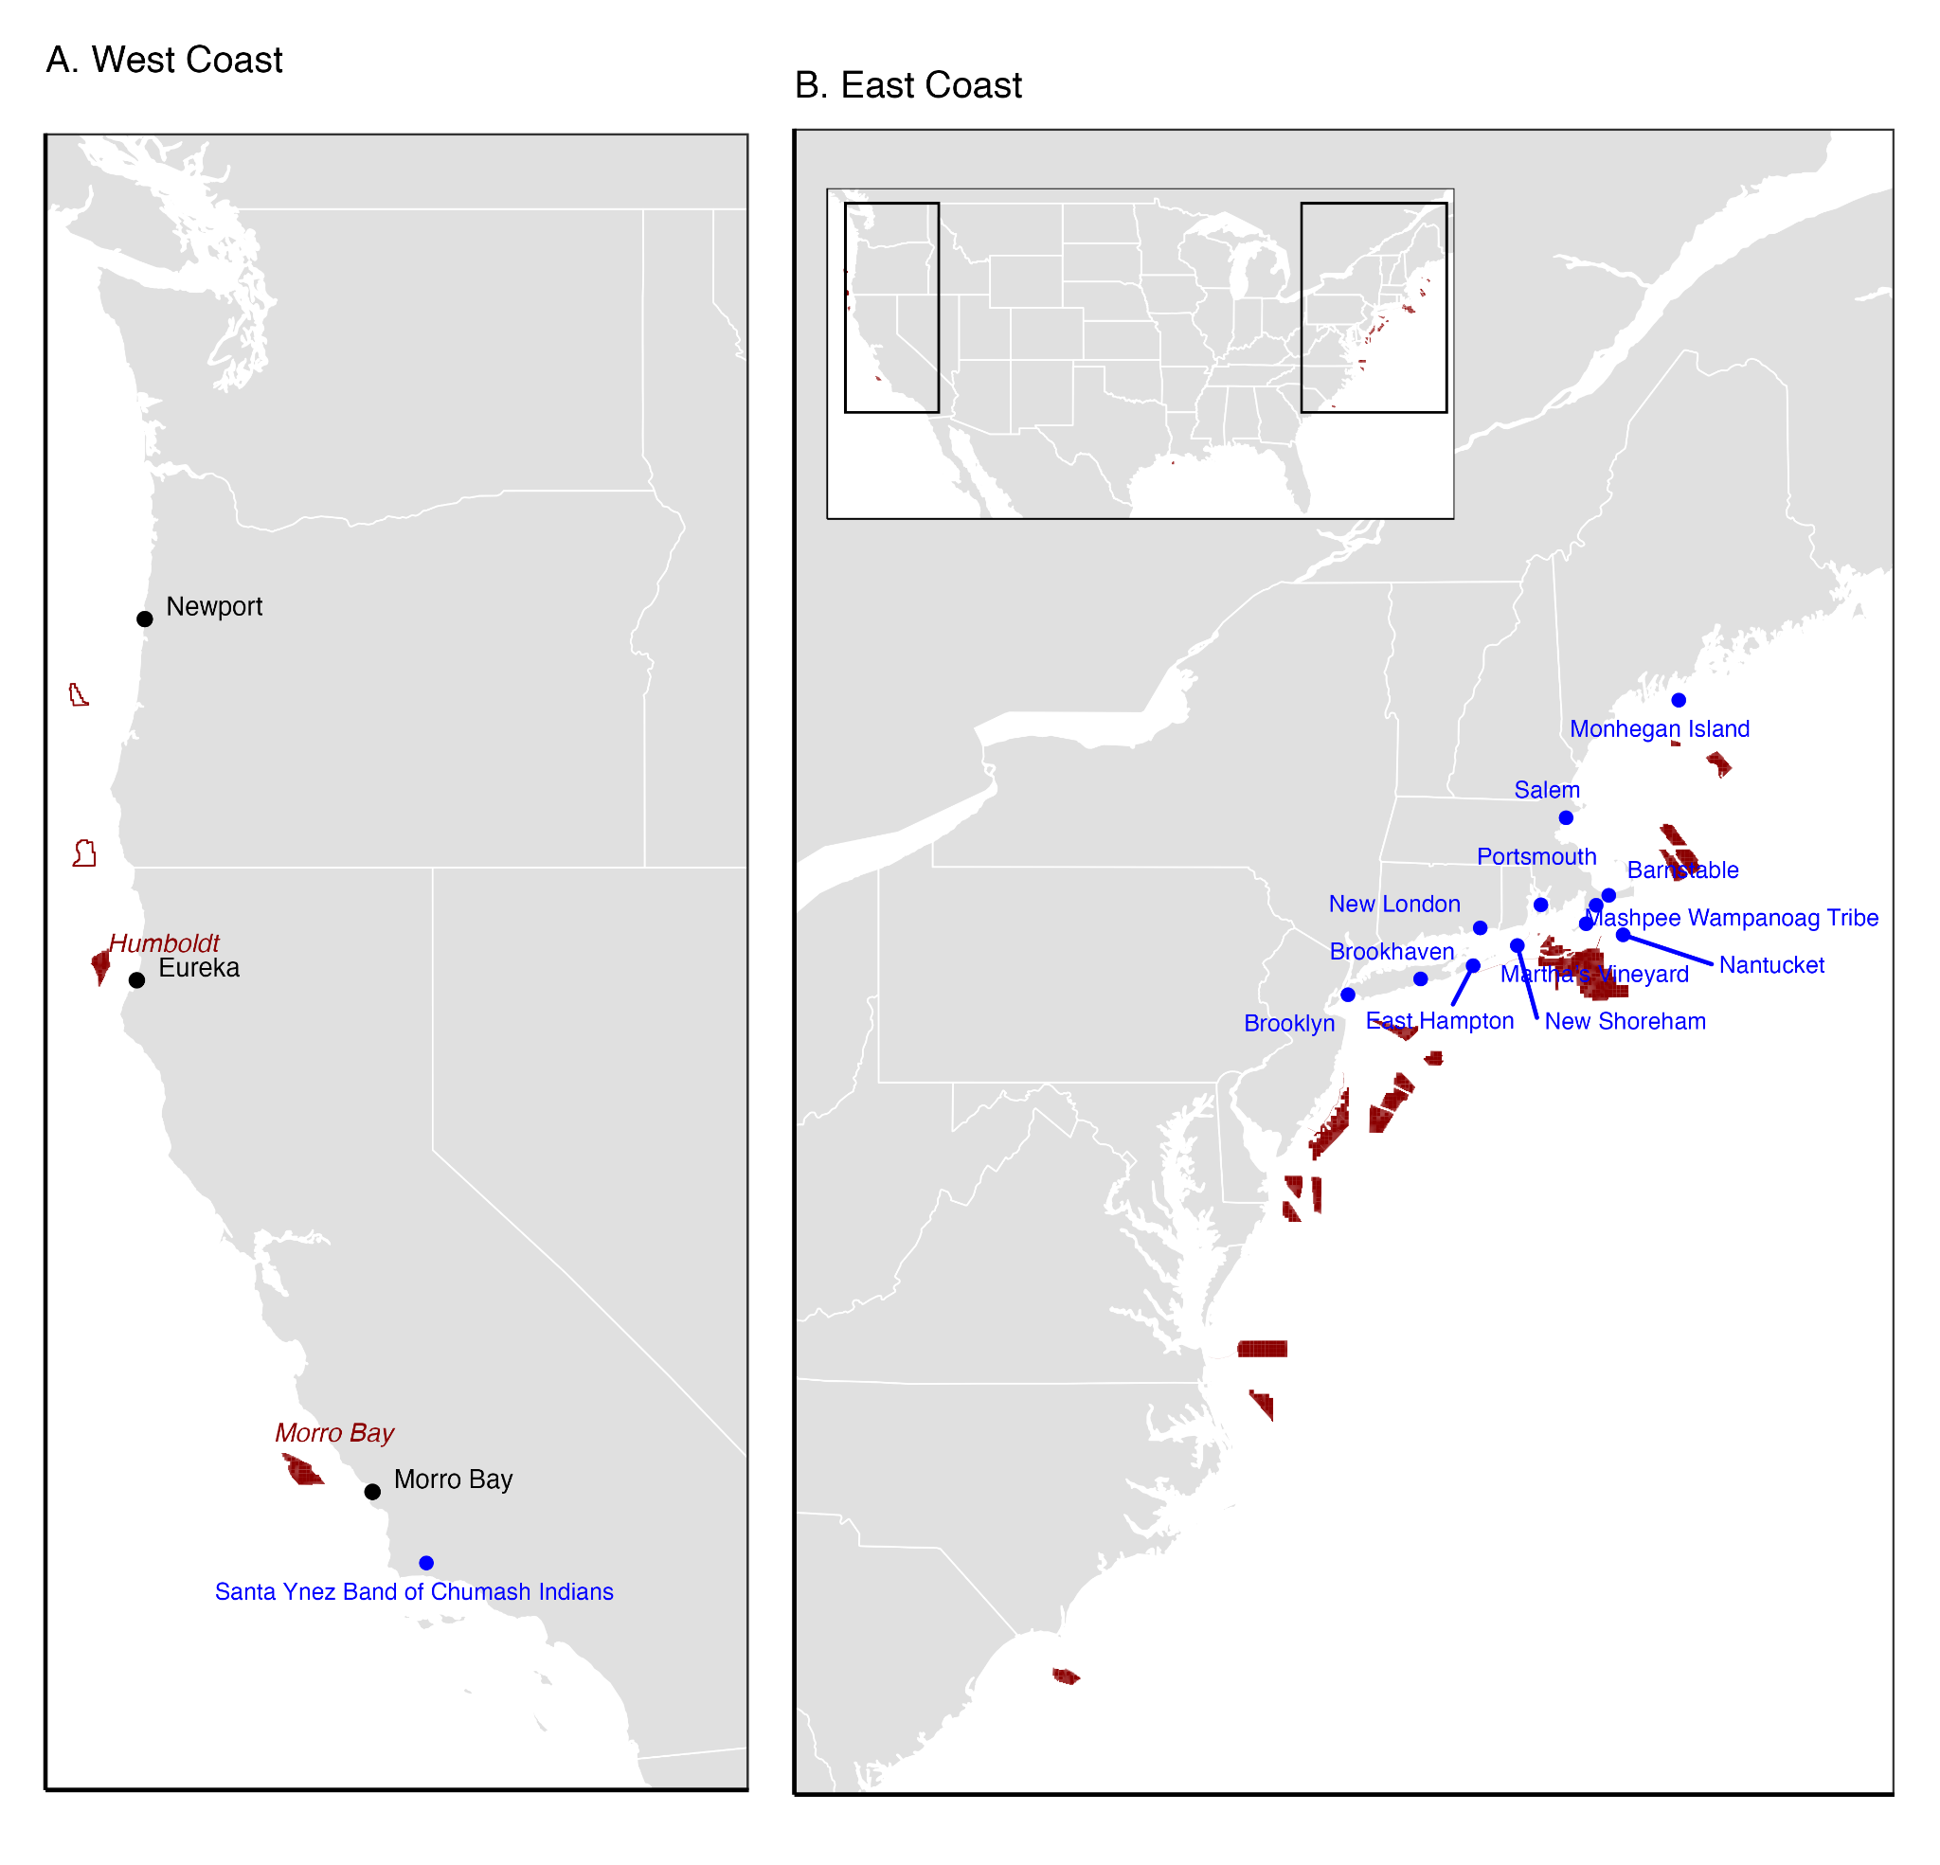
Figure 1. The location of offshore wind energy areas off the U.S. (A) West Coast and (B) East Coast. Maps show wind energy areas (red polygons and labels), places with community benefit agreements (CBAs) established between developers and communities (blue points and labels), and focus groups with West Coast fishing communities (black points and labels). On the West Coast, the hollow red polygons mark lease wind energy areas that were proposed when the focus groups were planned but were subsequently rescinded. The California wind energy areas are labelled.

- Fix title alignment issue

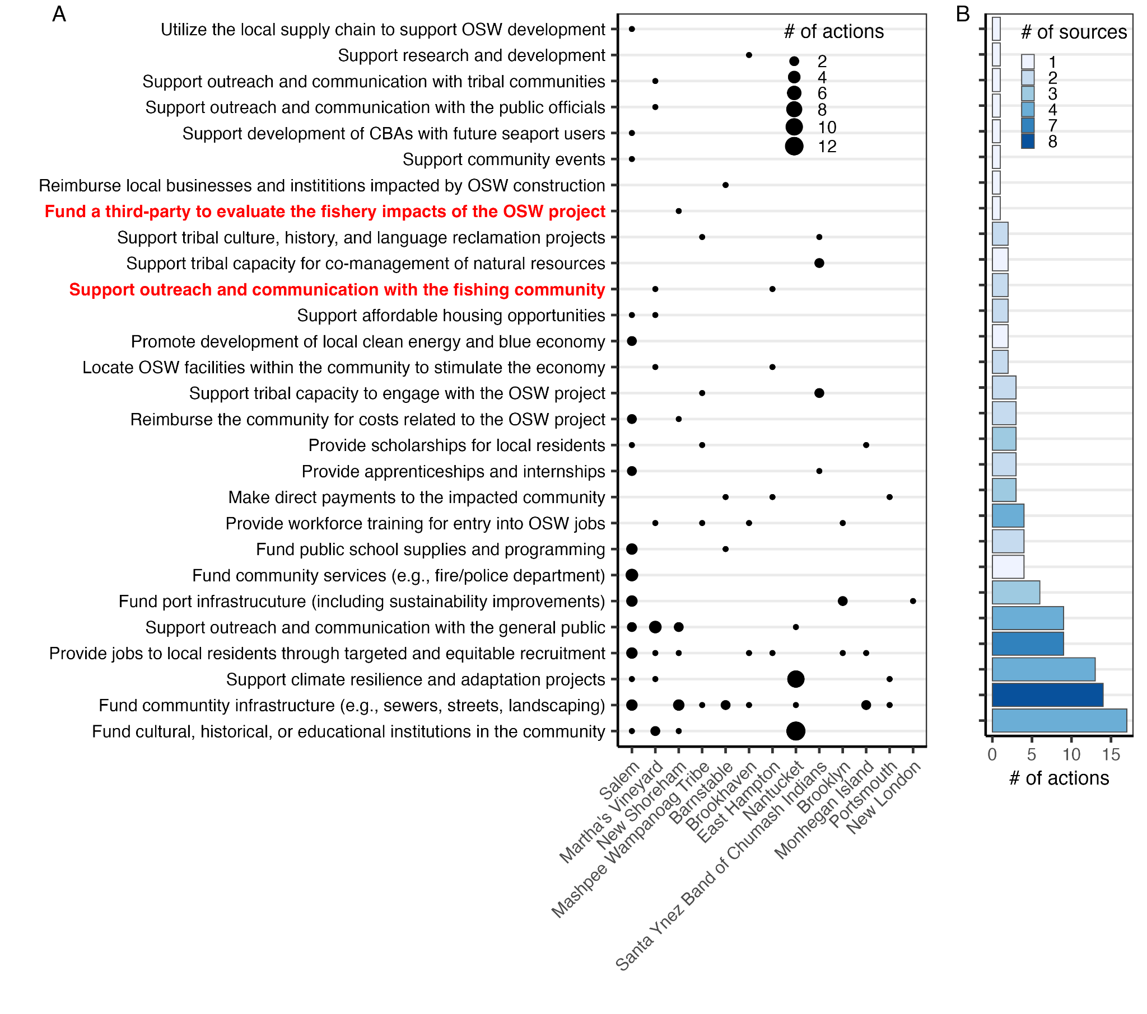Figure 2. The number of actions associated with different mitigation strategies from existing Community Benefit Agreements (A) by community and (B) across communities (see Fig. 1 for locations of the communities). Mitigation strategies shown in red are the only two strategies associated with fishing communities. Mitigation strategies are sorted by frequency of occurrence and communities are sorted by the number of mitigation strategies implemented by their CBA. Note that Barnstable has two CBAs (a primary and supplemental CBA with the same company).

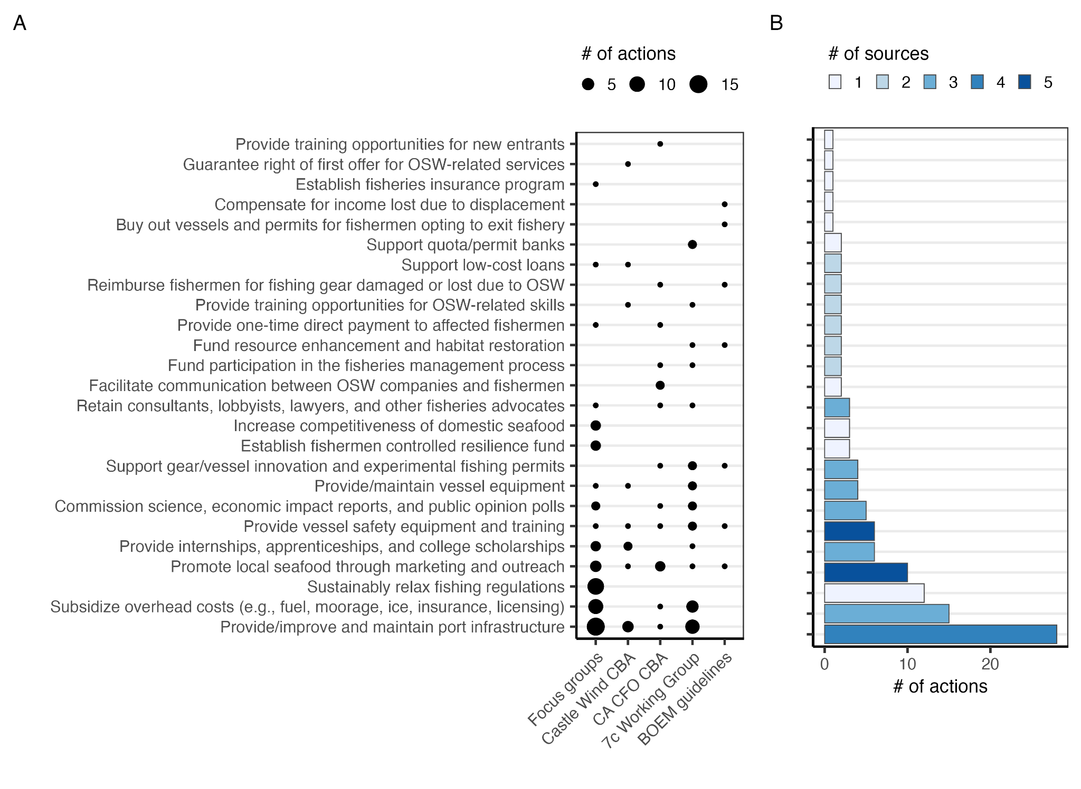Figure 3. The number of actions associated with different mitigation strategies (A) by source and (B) across sources. Acronyms: CBA=community benefit agreement; CA=California; CFO=commercial fishing organization; BOEM=Bureau of Ocean Energy Management.

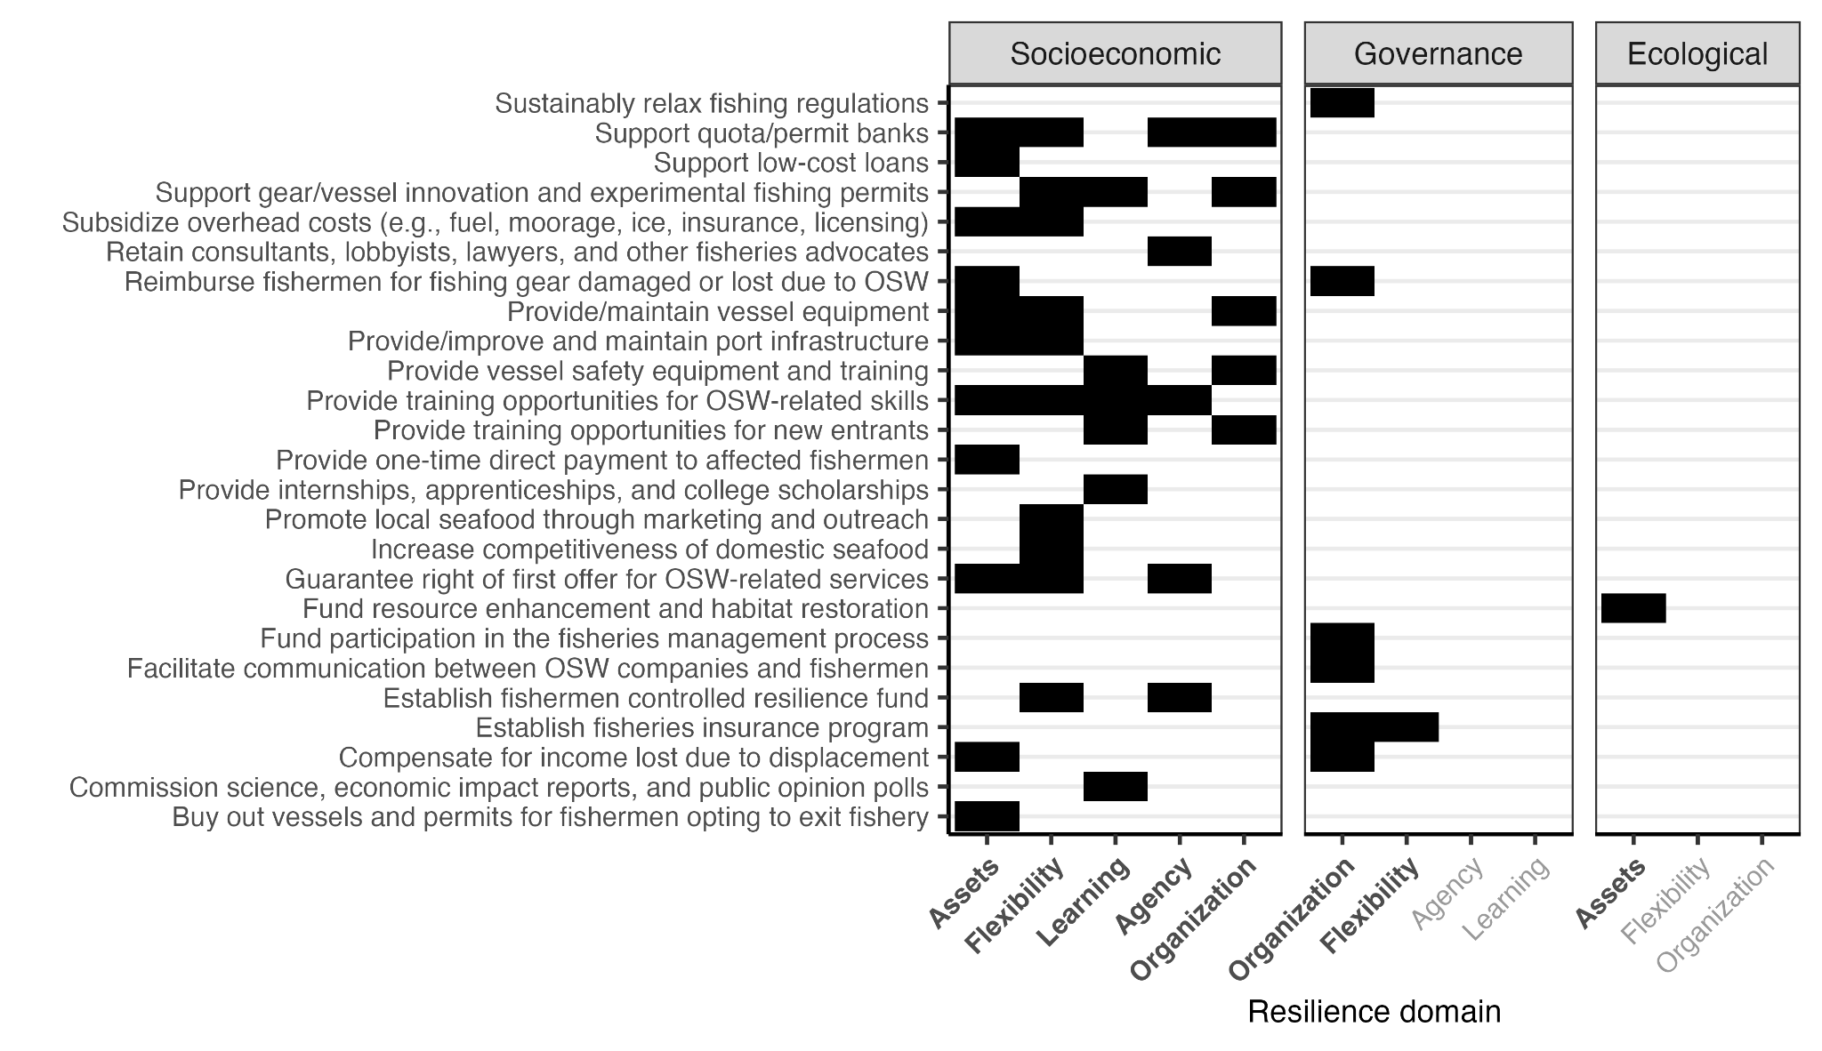Figure 4. Resilience domains supported by each mitigation strategy. Resilience domains are sorted by how frequently they are supported by a mitigation strategy; resilience domains supported by a mitigation strategy are bolded.

- Is there a meaningful way to organize the mitigation strategies (y-axis)? By most common (as in Fig. 3)? By most domains supported? By some theme?

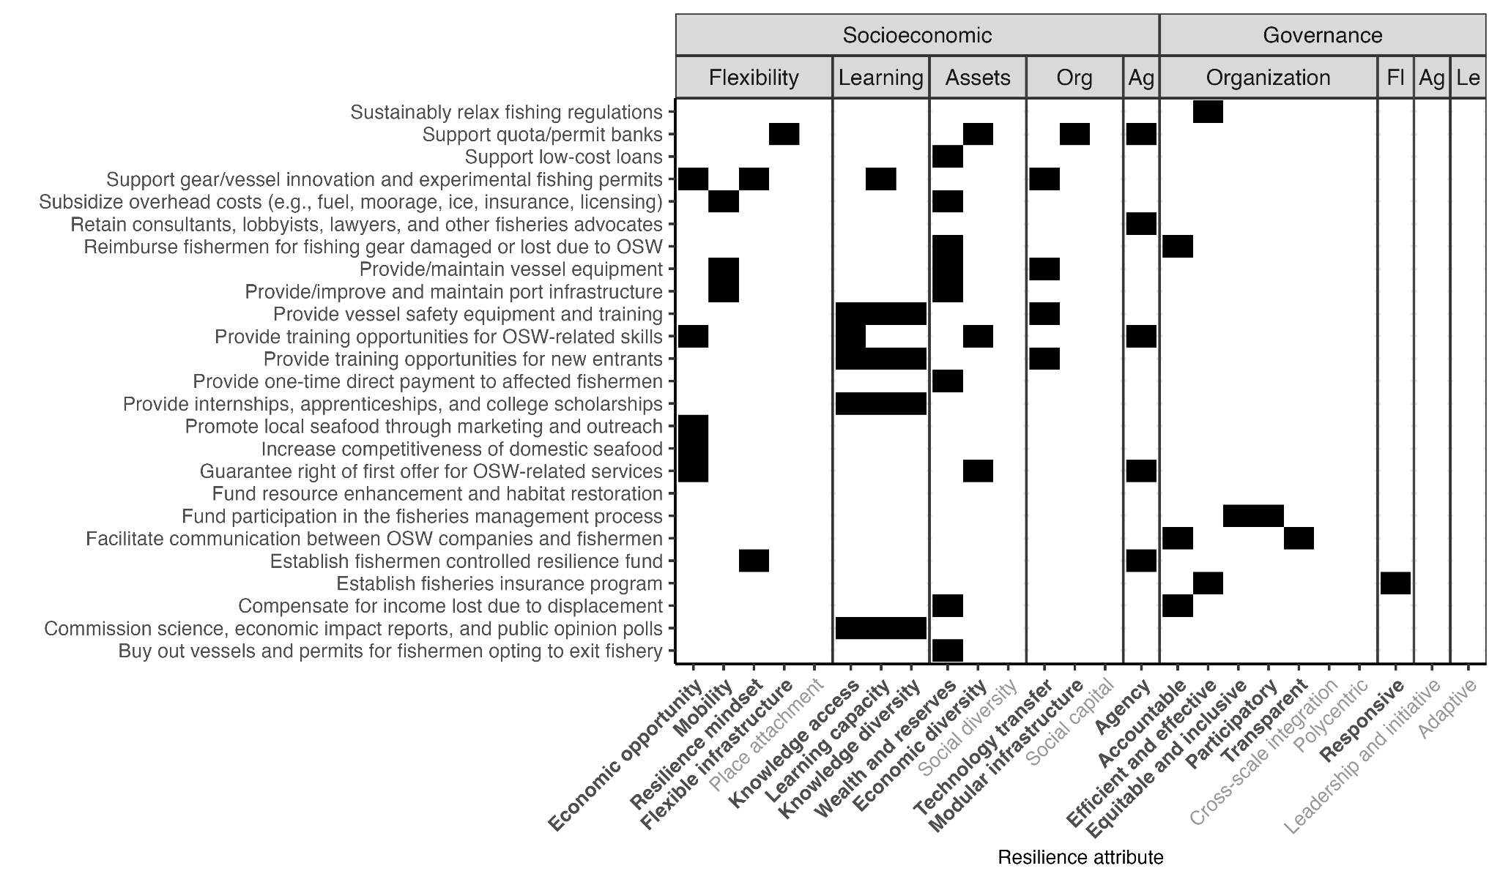Figure 5. Resilience attributes supported by each mitigation strategy. Attributes are organized by their dimension (socioeconomic, governance, ecological) and domain (agency [Ag], assets, flexibility, organization [Org], and learning [Le]) of climate resilience. Within their dimension and domain, attributes are sorted by how frequently they are supported by a mitigation strategy; resilience attributes supported by a mitigation strategy are bolded. The ecological dimension is suppressed for clarity but can be viewed in Figure S1. The only mitigation strategy to support ecological resilience is “Fund resource enhancement and habitat restoration.”

- Is there a meaningful way to organize the mitigation strategies (y-axis)? By most common (as in Fig. 3)? By most attributes supported? By some theme?

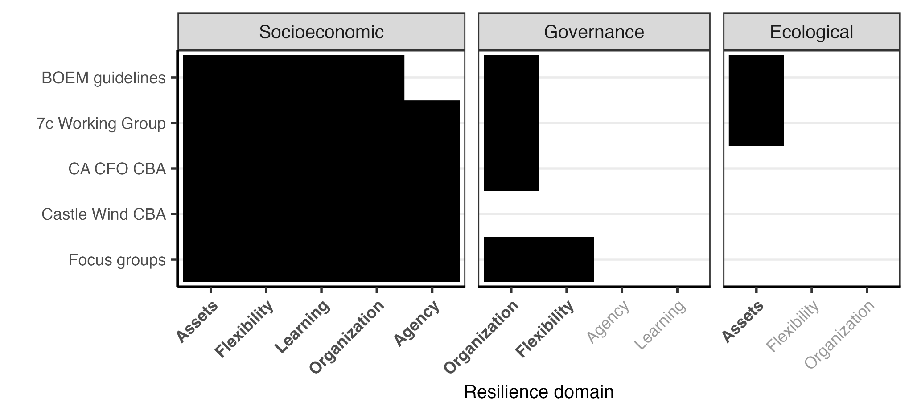
Figure 6. Resilience domains supported by mitigation strategies proposed within each source.
Resilience domains are sorted by how frequently they are supported by the sources; resilience domains supported by any source are bolded.

Supplemental Tables and Figures
Table S1. Characteristics of existing Community Benefit Agreements between offshore wind (OSW) developers and neighboring towns and tribes.

OSW developer | Community | State | Infrastructure type | Public (yes/no)?
CADEMO | Santa Ynez Band of Chumash Indians | CA | Project | No
North East Offshore | New London | CT | Port | Yes
Maine Aqua Ventus | Monhegan Island | ME | Project | Yes
New England Wind 1 | Barnstable | MA | Cable landing | Yes
Salem Wind Terminal | Salem | MA | Port | Yes
Vineyard Wind | Barnstable | MA | Cable landing | Yes
Vineyard Offshore | Mashpee Wampanoag Tribe | MA | Project | No
Vineyard Wind | Martha’s Vineyard | MA | Project | Yes
Vineyard Wind | Nantucket | MA | Project | Yes
Equinor/BP | Brooklyn | NY | Port | No
South Fork Wind | East Hampton | NY | Cable landing | Yes
Sunrise Wind | Brookhaven | NY | Cable landing | No
Deepwater Wind | New Shoreham | RI | Project | No
SouthCoast Wind Energy | Portsmouth | RI | Cable landing | Yes

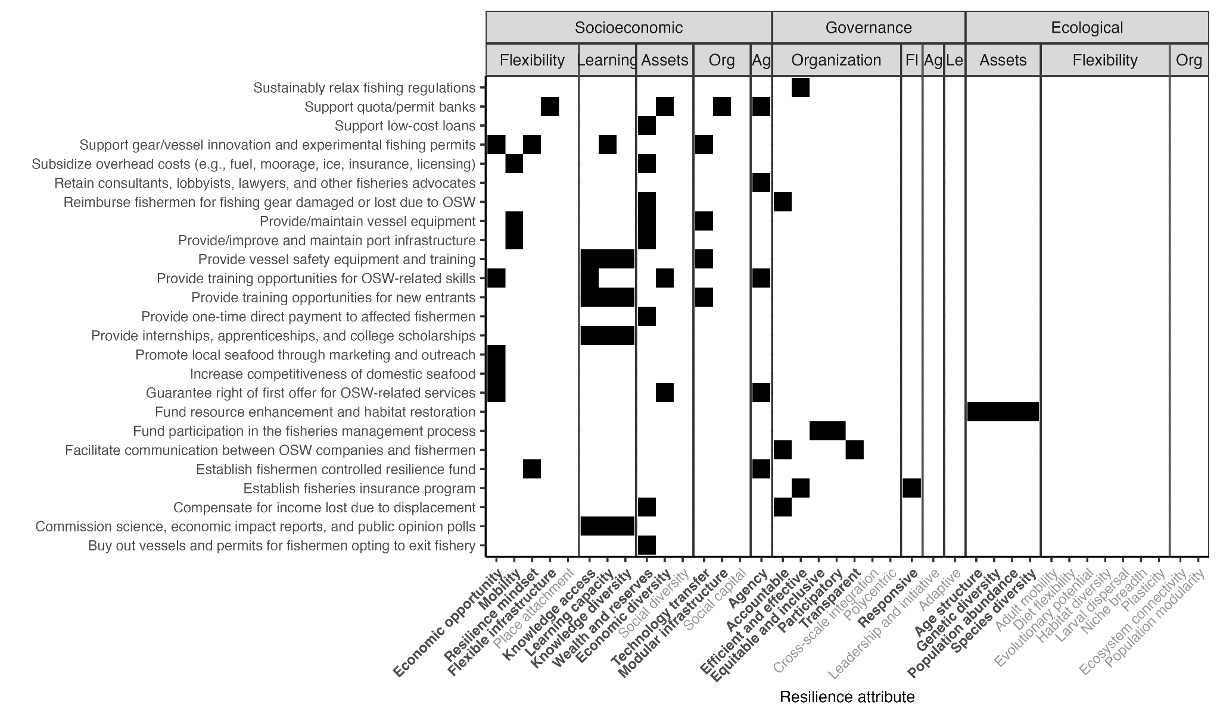Figure S1. Resilience attributes supported by each mitigation strategy. Attributes are organized by their dimension (socioeconomic, governance, ecological) and domain (agency [Ag], assets, flexibility, organization [Org], and learning [Le]) of climate resilience. Within their dimension and domain, attributes are sorted by how frequently they are supported by a mitigation strategy; resilience attributes supported by a mitigation strategy are bolded.

- Is there a meaningful way to organize the mitigation strategies (y-axis)? By most common (as in Fig. 3)? By most attributes supported? By some theme?

Appendix A: Focus group materials

Pre-focus-group preparation
Consulting group Strategic Earth worked through a preparation process with the two focus group facilitators (Willis-Norton and Mangin) from spring through late summer 2024. The team held an internal training series covering facilitation principles, the “Compassionate Communications for Facilitation and Daring Leadership” guidebook, group agreements, and the structured-discussion design that would be used in the field. A Training Guidebook was produced for the facilitators.

In parallel, Willis-Norton and Mangin ran a set of one-on-one informal “key communicator” conversations with experienced fishermen between May and June 2024. The 45-minute calls covered questions related to fishermen’s needs with respect to research on climate change and OSW, pitfalls and red flags to watch for in focus-group design, who to engage at each port, and timing conflicts (e.g., fishing seasons). These calls served two purposes: they shaped the focus-group design, and they began the relationship-building process with the sector. Based on this information and training, the team developed a Process Design memo to organize the focus-group vision, engagement strategies, agenda framework, and explicit goals for evaluating success.

Participant outreach and recruitment
Outreach combined direct invitations to fishermen who had previously talked with members of the team, an open invitation that fishermen and fishing-community partners could forward to peers, and BCC distribution to local contact lists at each port. The invitation email described the focus group, attached the participant agenda and the project backgrounder, and offered a $200 stipend. Registration was open until Friday, September 6, 2024. The recruitment language was explicit about the target population: commercial fishermen who would be “directly impacted by on-water changes from shifting ocean conditions and offshore wind development.”
Interested participants were not limited to the target population, and the team made one-off decisions on participation for registrants who were not commercial fishermen. For example, a senior advisor to a major Pacific Northwest seafood processor was asked instead to meet one-on-one before the focus group. These decisions were made to keep the conversation focused on on-water impacts rather than on processing, harbor administration, or industry policy. An exception was made for a city/harbor-department staff member who attended a focus group and contributed their perspective on local infrastructure, slip occupancy, and community.
The Process Design memo identified an explicit goal of involving younger fishermen (under age 50) who had not yet participated in OSW discussions. The September 2024 cohort skewed older, with several participants explicitly raising the aging of the fleet and difficulty for younger fishermen to enter the industry as a central concern (Section 4). A thank-you email was sent to each participant after their meeting and included a one-minute survey for feedback on the focus-group experience.

Focus group structure
All three focus groups followed the same agenda and were facilitated in person by Willis-Norton, Mangin, and a representative from Strategic Earth for general support. The half-day format and shared structure were deliberate: the goal was that themes across sites could be compared rather than confounded by methodology.

The agenda was:

- Welcome and Introductions. Participants and facilitators introduced themselves; the team set out group agreements and intentions for the session. A light breakfast was provided. Participants were encouraged to provide extended self-introductions in which fishermen described their fisheries, vessels, and family histories.
- Project Overview. Facilitators gave a short presentation on the study’s purpose, approach, and partnerships, followed by open Q&A on participant concerns about both climate change and OSW development.
- Discussing Changing Ocean Conditions. Participants and facilitators engaged in group discussion of past, current, and anticipated future impacts of changing ocean conditions on the local fishery and fishing community. Discussion questions included: “Have you experienced recent changes in ocean conditions or extreme weather events? If so, how has it impacted your fishing experience? What resources have you wanted or needed during these periods? How do you expect conditions to change in the future, if at all? What concerns do you have about the future? Do you anticipate any new opportunities?”
- Considering Offshore Wind Farm Development. Participants and facilitators engaged in group discussion of opinions, beliefs, and attitudes toward proposed OSW farms, including the specific lease areas relevant to each site. The team shared a list of potential impacts compiled from the literature review and asked participants to add missing impacts.
- Exploring Mitigation Strategies. Facilitators led a structured brainstorm and prioritization of potential mitigation strategies to enhance commercial fishery resilience. Mitigation candidates were grouped into themed flip charts (categories established in the initial Eureka session and reused at the subsequent sites included data and monitoring, infrastructure and shoreside support, regulation and policy, enforcement and accountability, design, community investment and involvement, industry, and avoidance). Individual participants wrote their highest-priority strategies on sticky notes. The agenda also planned a sticky-dot prioritization exercise. This exercise was conducted as planned at some sites and supplanted by direct group dialogue at others depending on the group’s preference and available time.
- Thank You and Lunch. Participants were invited to join for an informal lunch where next steps were discussed.

Discussion was captured live on flip-chart paper by Willis-Norton, Mangin, and the Strategic Earth representative. Both Willis-Norton and Mangin took independent meeting notes. Photographs of flip charts and sticky notes were taken before tear-down.

